**Analysis Document Chicago**

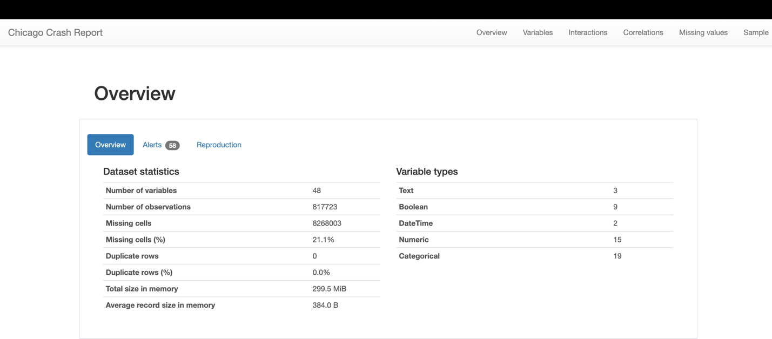

**Dataset Overview**: The dataset includes 48 variables, 817,723 observations, and 8,268,003 missing cells, which represent 21.1% of all data. It has no duplicate rows and takes up approximately 299.5 MiB in memory.

* **Variable Types**: The variables include 3 text, 9 Boolean, 2 DateTime, 15 numeric, and 19 categorical data types.
* **Alerts for Variables**: Certain variables like "INJURIES_UNKNOWN" have constant values, which means they don’t change across the dataset. Others, like "LANE_CNT" and "STREET_NO", show high correlation with multiple fields, indicating a strong relationship between these variables.
* **Imbalance in Data**: Some variables, such as "TRAFFIC_CONTROL_DEVICE" and "DEVICE_CONDITION", are highly imbalanced, which means that some values occur much more frequently than others.
* **Missing Values**: There's a significant amount of missing data, especially in fields like "CRASH_DATE_EST_I" and "LANE_CNT", where over 75% of the values are missing.
* **Skewed Variables**: "LANE_CNT", "LATITUDE", and "LONGITUDE" are highly skewed, meaning their distributions are not symmetrical around the mean.
* **Unique and Zero Values**: "CRASH_RECORD_ID" has unique values across the dataset. Some injury-related variables have a large proportion of zeros, which may indicate many reported crashes did not result in injuries.
* **Analysis Details**: The analysis was conducted using ydata-profiling software and took approximately 4 minutes and 33 seconds to complete.
* **CRASH_DATE Variable**: It's a Date type variable with over half a million distinct dates ranging from March 3, 2013, to March 26, 2024.
* **Interactions**: The report also includes interactions between various variables like "POSTED_SPEED_LIMIT", "LANE_CNT", "STREET_NO", "BEAT_OF_OCCURRENCE", and "INJURIES_TOTAL", among others.

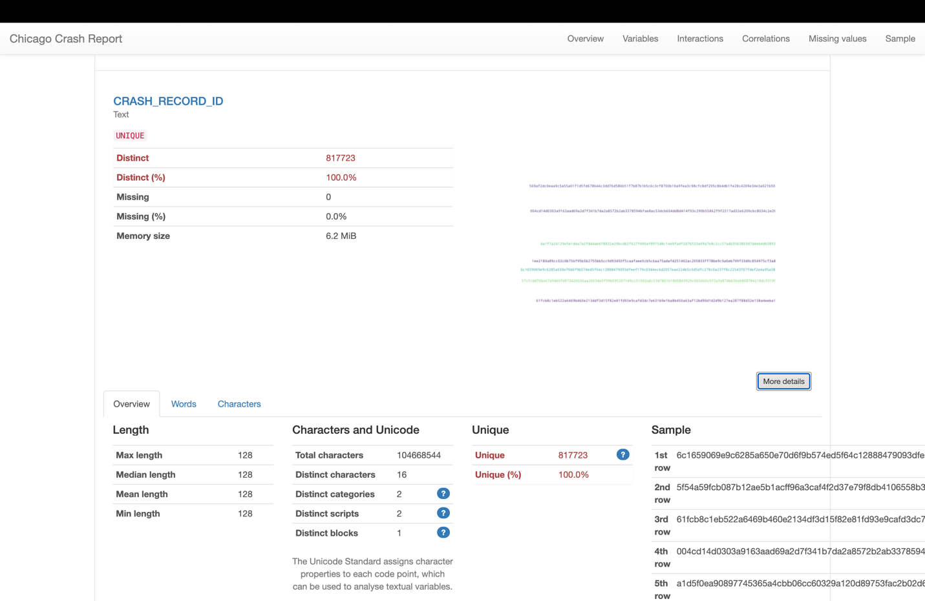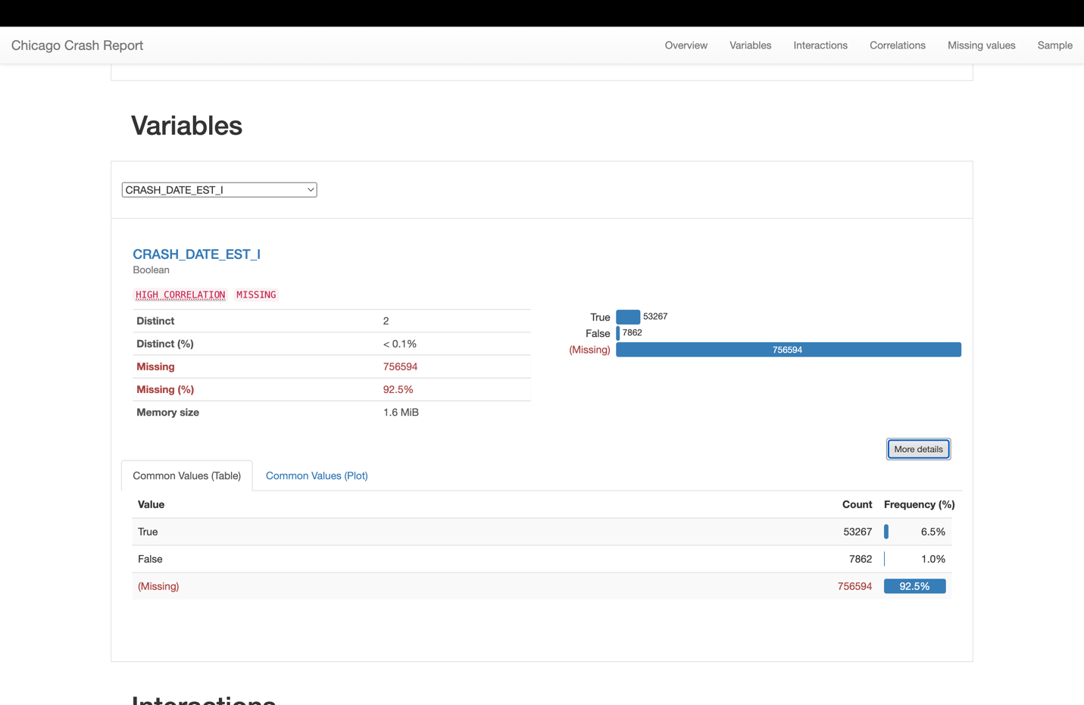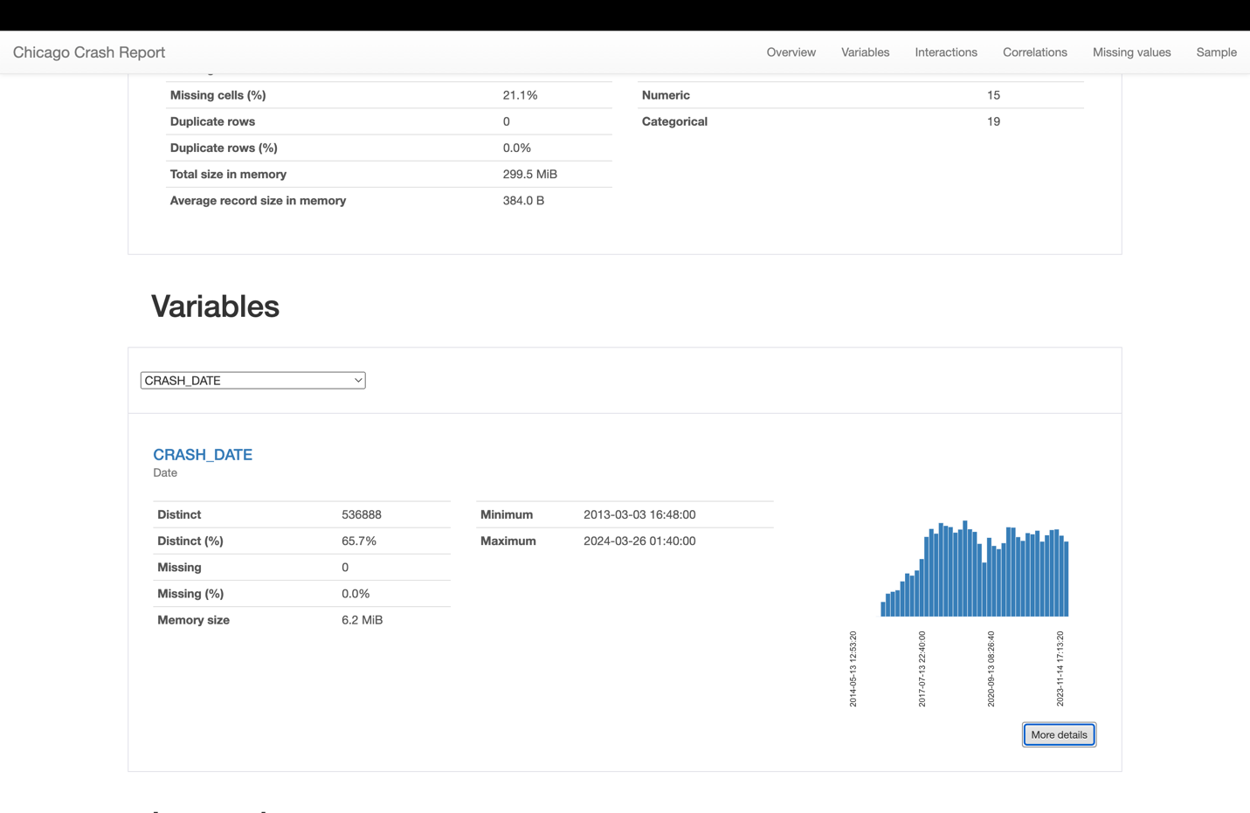

* **Data Completeness:**
  1. **WEATHER_CONDITION**: No missing entries; complete data set for weather conditions during crashes.
  2. **DEVICE_CONDITION**: Fully recorded with no missing entries, indicating reliable information on the state of traffic control devices.
  3. **TRAFFIC_CONTROL_DEVICE**: All entries are accounted for, providing comprehensive data on traffic control presence.
* **Distinct Values:**
  1. **WEATHER_CONDITION**: Contains 12 distinct types of weather conditions.
  2. **DEVICE_CONDITION**: Comprises 8 different conditions of traffic control devices.
  3. **TRAFFIC_CONTROL_DEVICE**: Encompasses 19 distinct traffic control devices.
  4. **POSTED_SPEED_LIMIT**: 46 unique posted speed limits are represented, ranging from 0 to 99.
* **Variable Characteristics:**
  1. **CRASH_DATE**: Dates range from March 3, 2013, to March 26, 2024, with a total of 536,888 distinct dates, providing a vast timeline of crash data.
  2. **CRASH_RECORD_ID**: Every entry is unique across the 817,723 records, ensuring the precision of crash identification.
  3. **POSTED_SPEED_LIMIT**: The average speed limit in the data is approximately 28.4, with values spread across the permissible range, and a negligible amount (0.9%) of entries with a zero speed limit.
* **Data Integrity:**
  1. The dataset shows no duplicate rows, ensuring that each record is unique and there is no redundant information.
  2. Memory utilization is consistently around 6.2 MiB for categorical variables, which is efficient for dataset analysis.

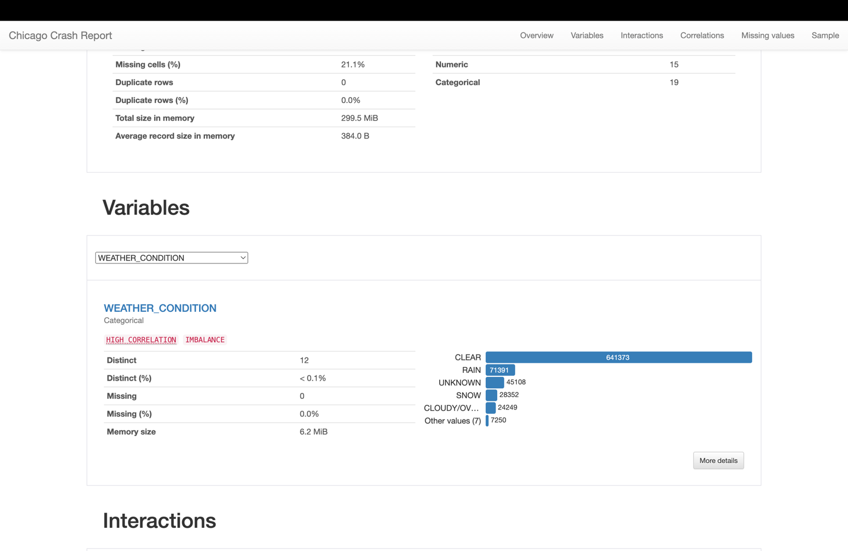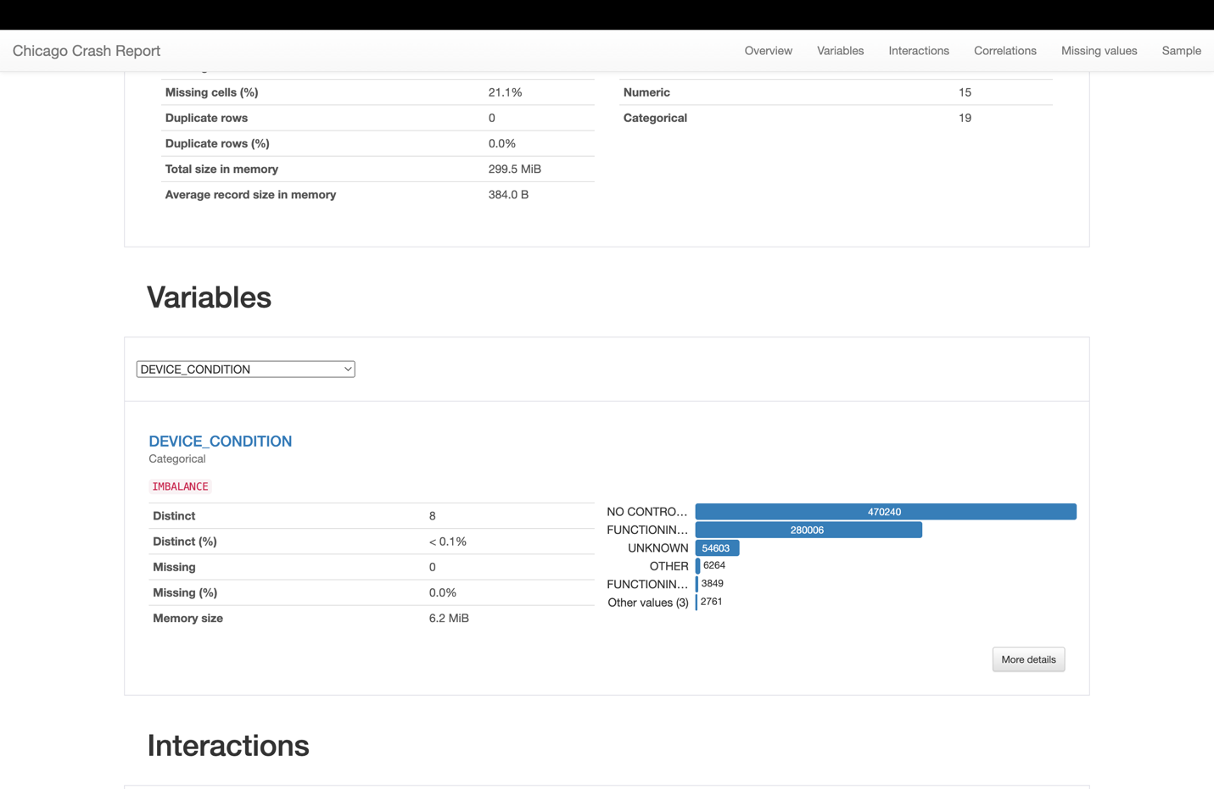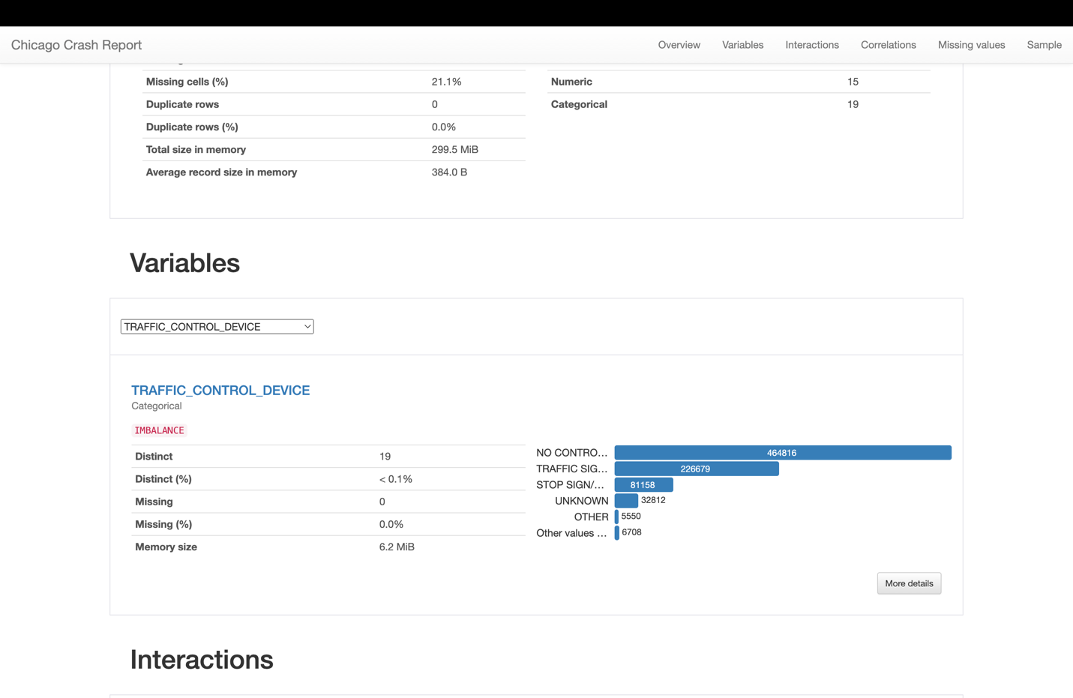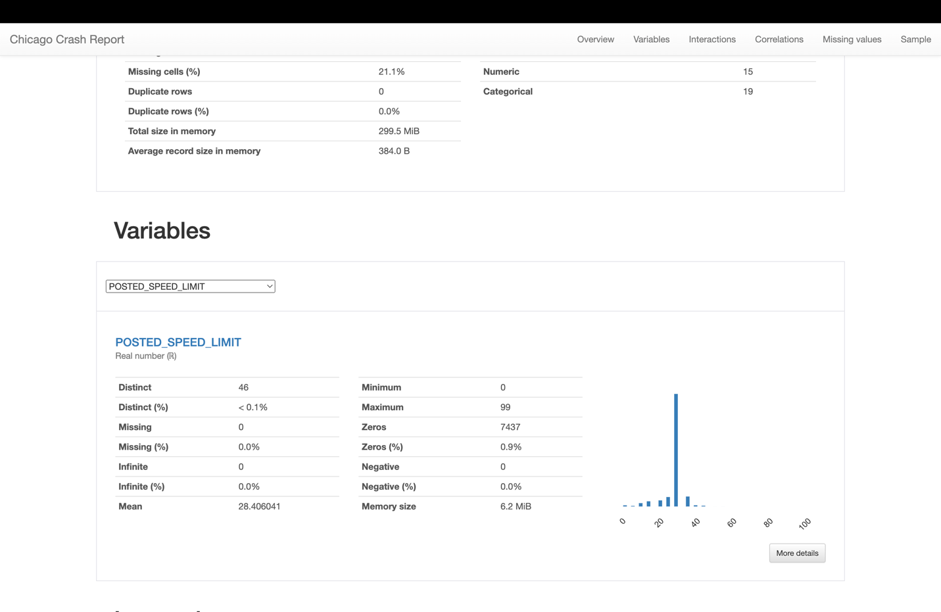

**CRASH_RECORD_ID**

* **Distinct Values**: 817,723 (Every entry is unique, indicating a unique identifier for each crash record).
* **Missing Data**: 0% (Indicates that this field is consistently recorded and complete for all records).
* **Characteristics**: Text type with a fixed length of 128 characters for each ID.

**POSTED_SPEED_LIMIT**

* **Distinct Values**: 46 (Reflects the diversity of speed limits at crash sites).
* **Missing Data**: 0% (Full data availability, essential for analyzing speed-related factors in crashes).
* **Data Type**: Numeric (Speed limit values).

**TRAFFIC_CONTROL_DEVICE**

* **Distinct Values**: 19 (Shows the variety of traffic control devices present where crashes occurred).
* **Missing Data**: 0% (Complete records, allows for the assessment of device presence and effectiveness).

**DEVICE_CONDITION**

* **Distinct Values**: 8 (This range could indicate various states of traffic control devices from functional to non-existent).
* **Missing Data**: 0% (Every crash report includes the condition of the traffic device, if applicable).

**WEATHER_CONDITION**

* **Distinct Values**: 12 (Represents different weather conditions during the time of the crash).
* **Missing Data**: 0% (No missing entries, crucial for understanding weather impacts on road safety).

**CRASH_DATE**

* **Distinct Values**: 536,888 (A high number of unique dates and times suggesting detailed records over time).
* **Missing Data**: 0% (Indicating accurate and complete logging of crash occurrences).

**CRASH_DATE_EST_I**

* **Distinct Values**: 2 (Boolean values indicating whether the crash date is estimated).
* **Missing Data**: 92.5% (Most records do not have an estimation flag, implying exact dates are known).

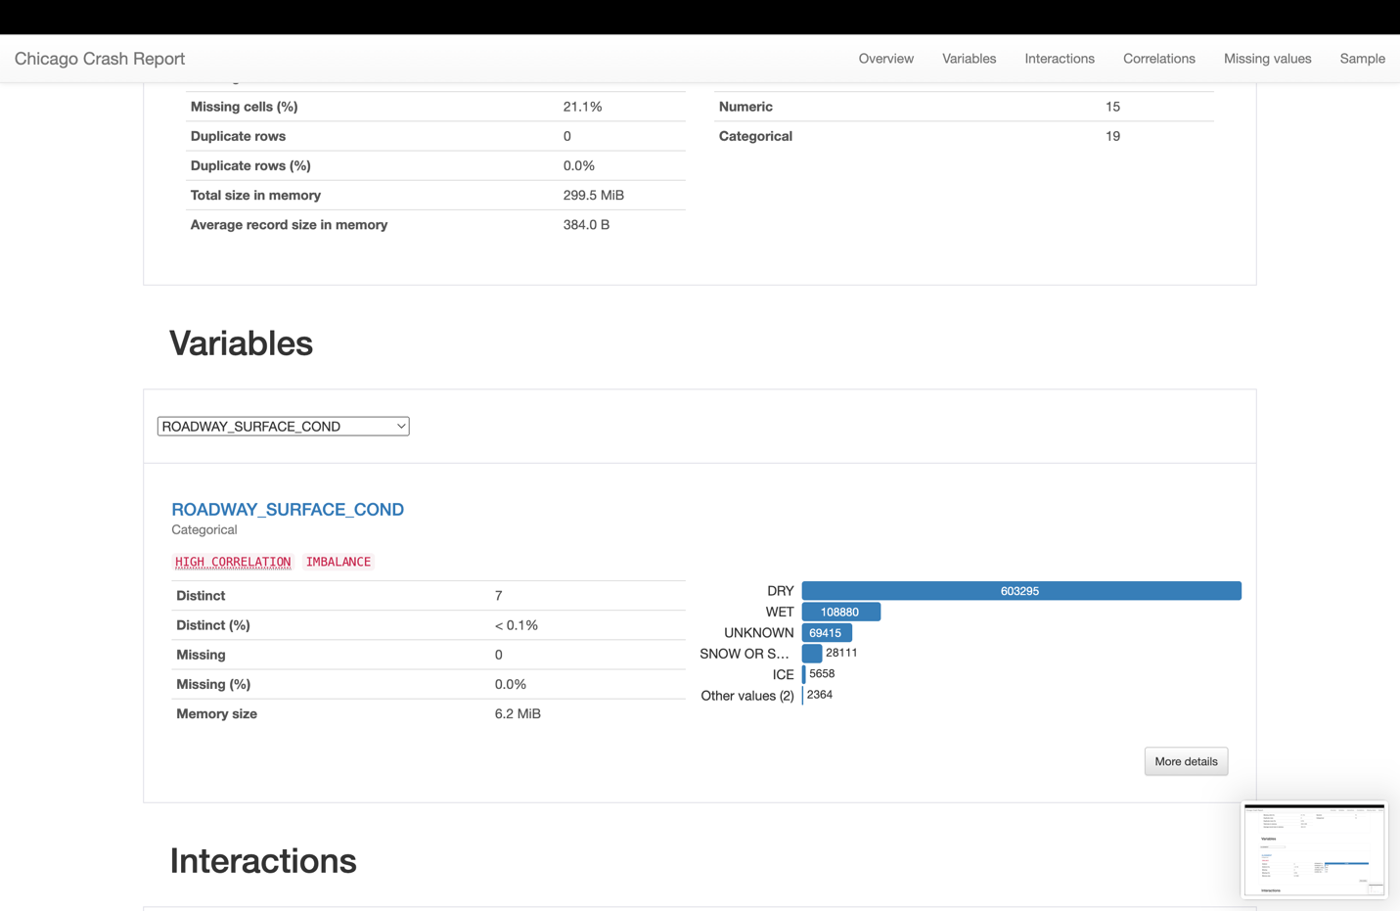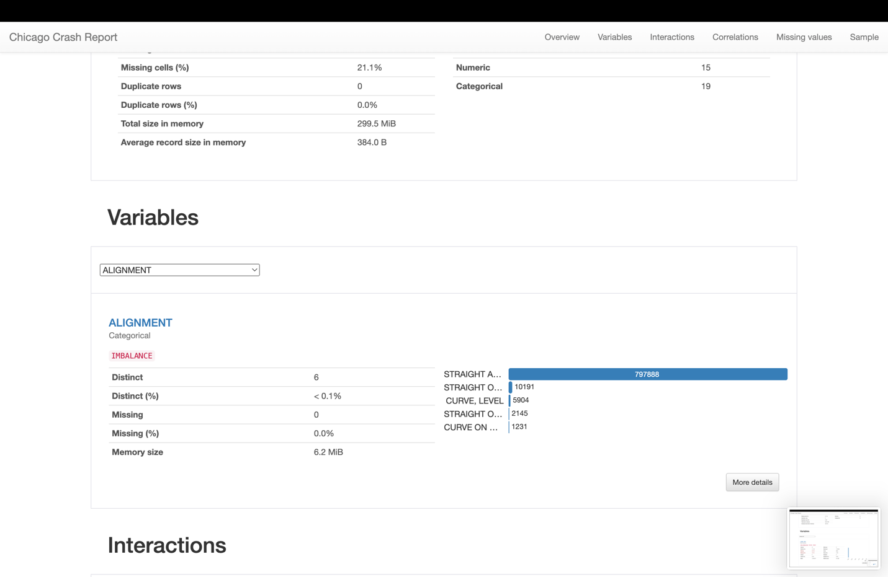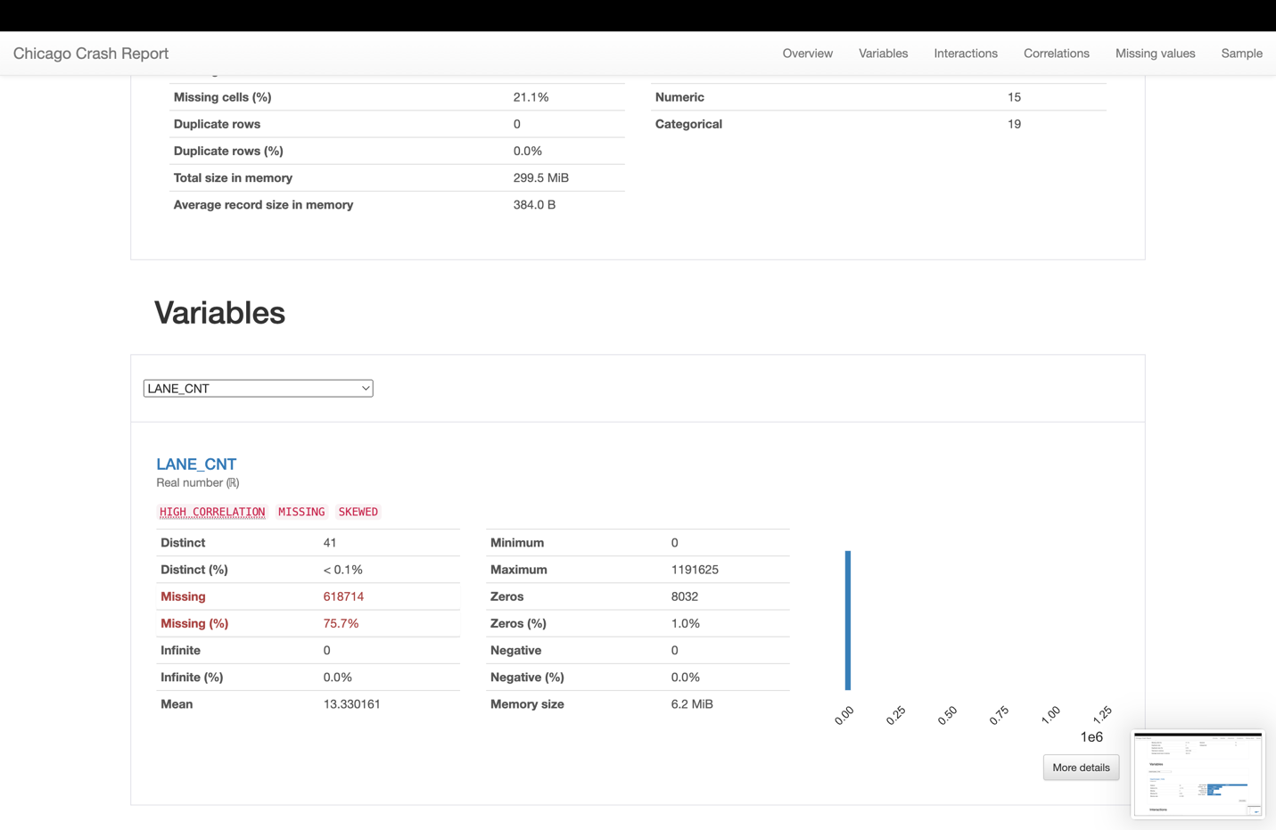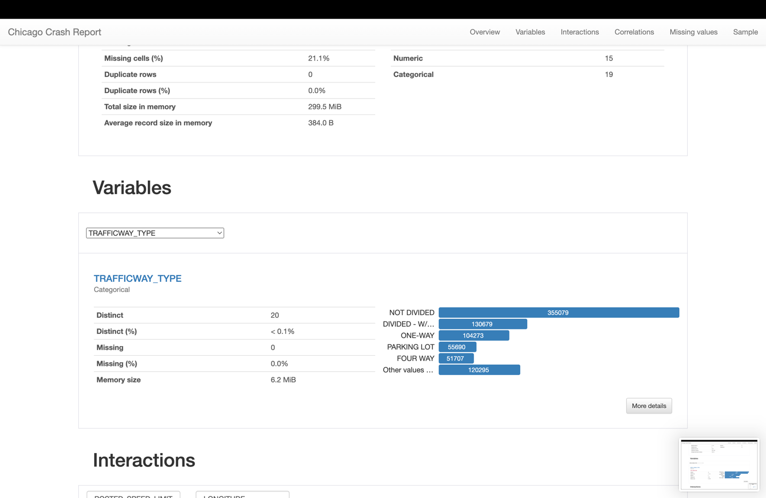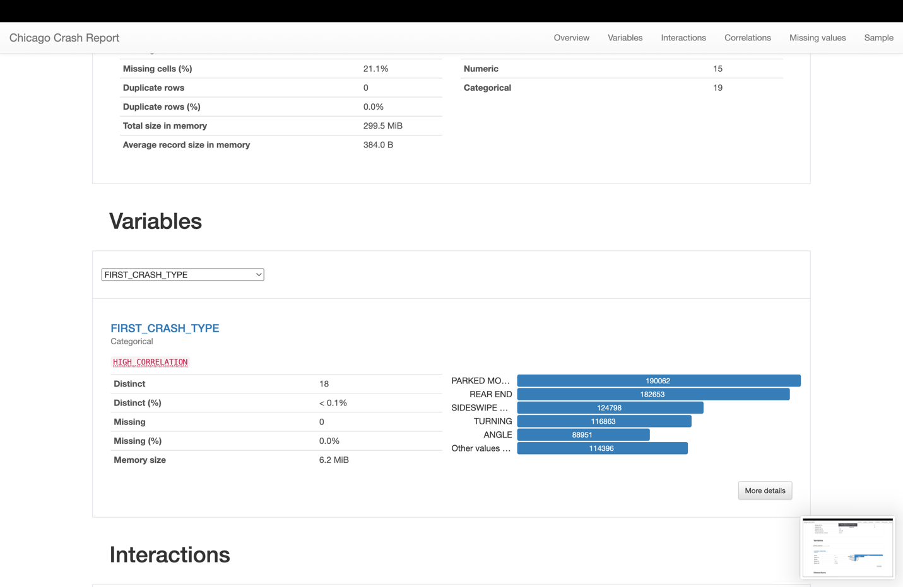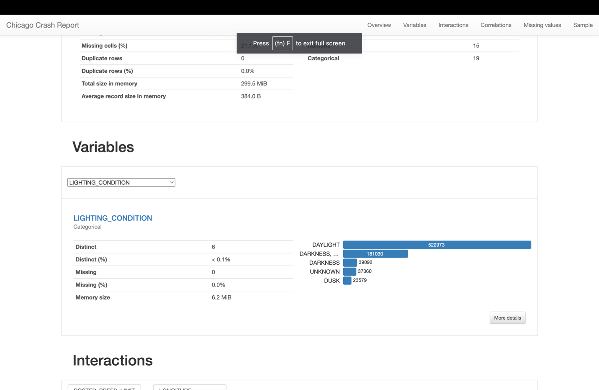

**ROADWAY_SURFACE_COND**

* Data Completeness: There are no missing entries, which suggests complete data collection for this variable.
* Distinct Values: There are 7 distinct surface conditions recorded, implying a variety of road conditions are considered in the dataset.
* Most Common Values: "Dry" conditions have the highest count, indicating most incidents occurred when the road was dry.

**ALIGNMENT**

* Data Completeness: Complete data with no missing entries.
* Distinct Values: 6 distinct alignments suggest the data captures various road alignments where crashes occurred.
* Most Common Values: "Straight and Level" has the highest count, indicating it is the most common road alignment where incidents happened.

**LANE_CNT**

* Data Completeness: About 75.7% of the entries are missing, which could significantly impact the analysis involving lane count.
* Distinct Values: 41 distinct values for lane count.
* Mean Value: The average lane count is approximately 13.33, but this value could be misleading due to the high number of missing entries.

**TRAFFICWAY_TYPE**

* Data Completeness: No missing entries, which is excellent for analysis.
* Distinct Values: 20 distinct types show a broad classification of trafficway types in the dataset.
* Most Common Values: "Not Divided" and "Divided - With Median" are the most common types, suggesting where most incidents occur.

**FIRST_CRASH_TYPE**

* Data Completeness: There are no missing entries for crash type.
* Distinct Values: 18 distinct crash types indicate a detailed classification of crash scenarios.
* Most Common Values: "Parked Motor Vehicle" incidents are the most common, followed by "Rear End" and "Sideswipe" incidents.

**LIGHTING_CONDITION**

* Data Completeness: Complete data with no missing entries.
* Distinct Values: 6 distinct lighting conditions suggest the dataset captures various times of day and lighting situations.
* Most Common Values: "Daylight" has the highest count, indicating that most crashes occurred during the day.

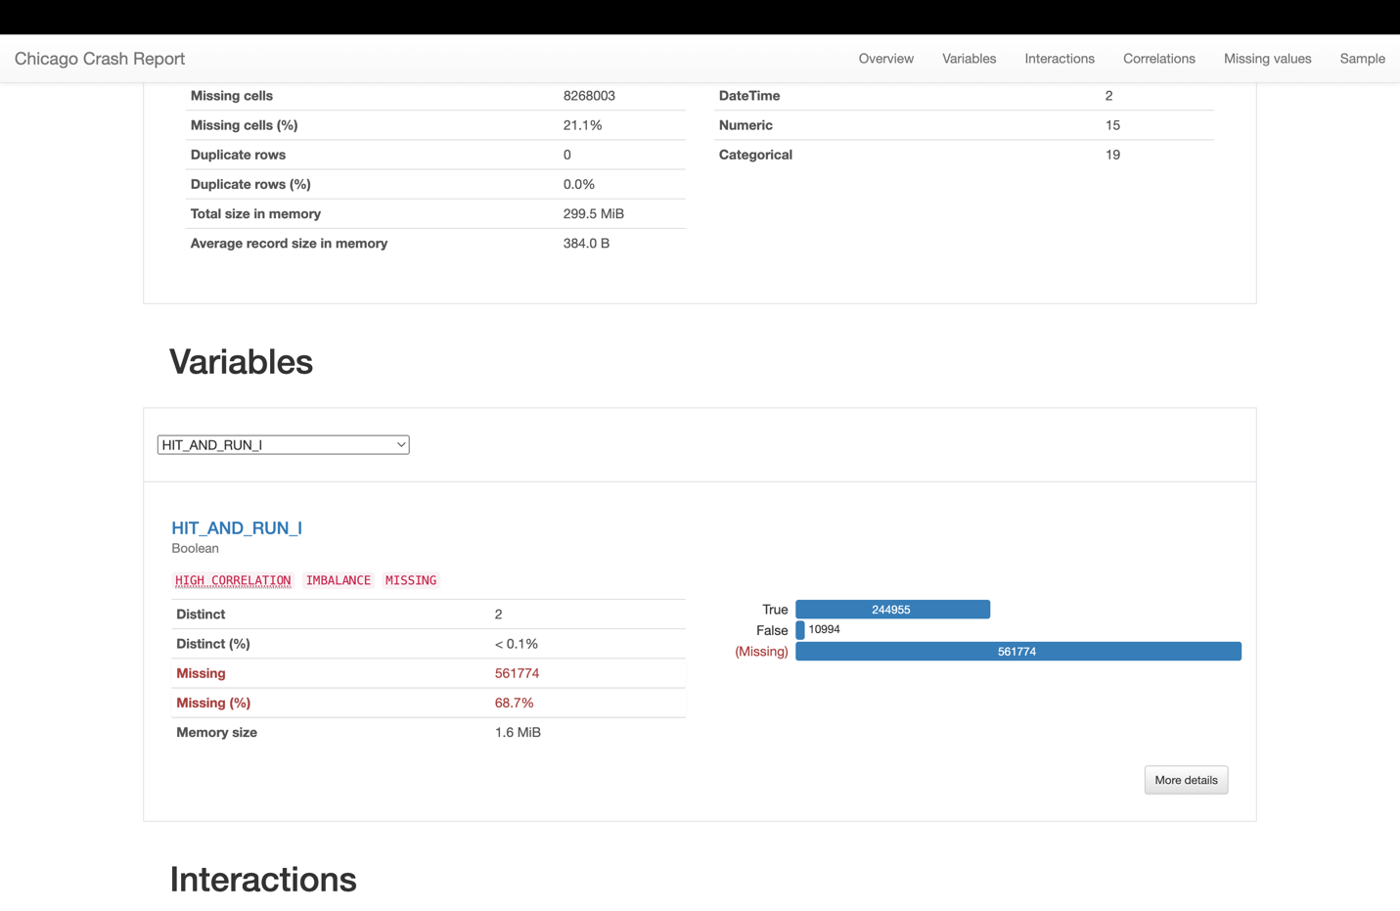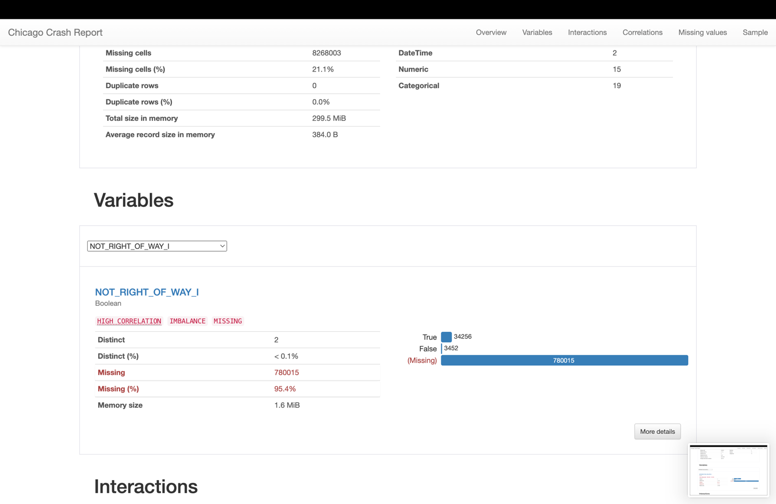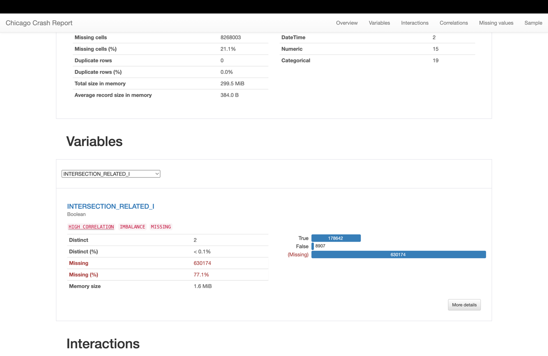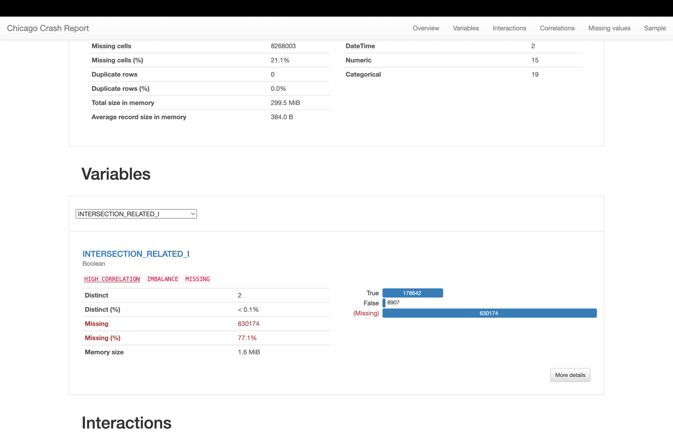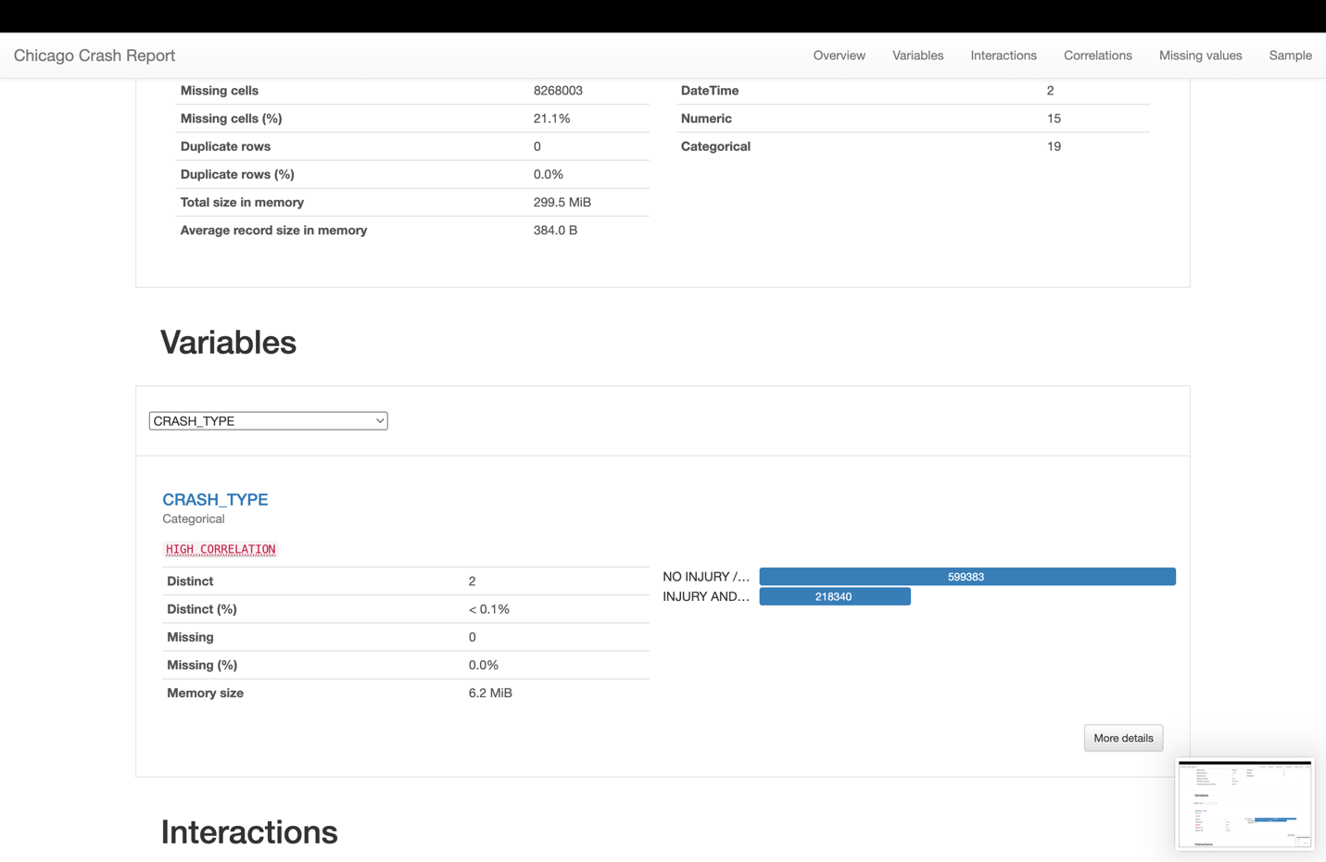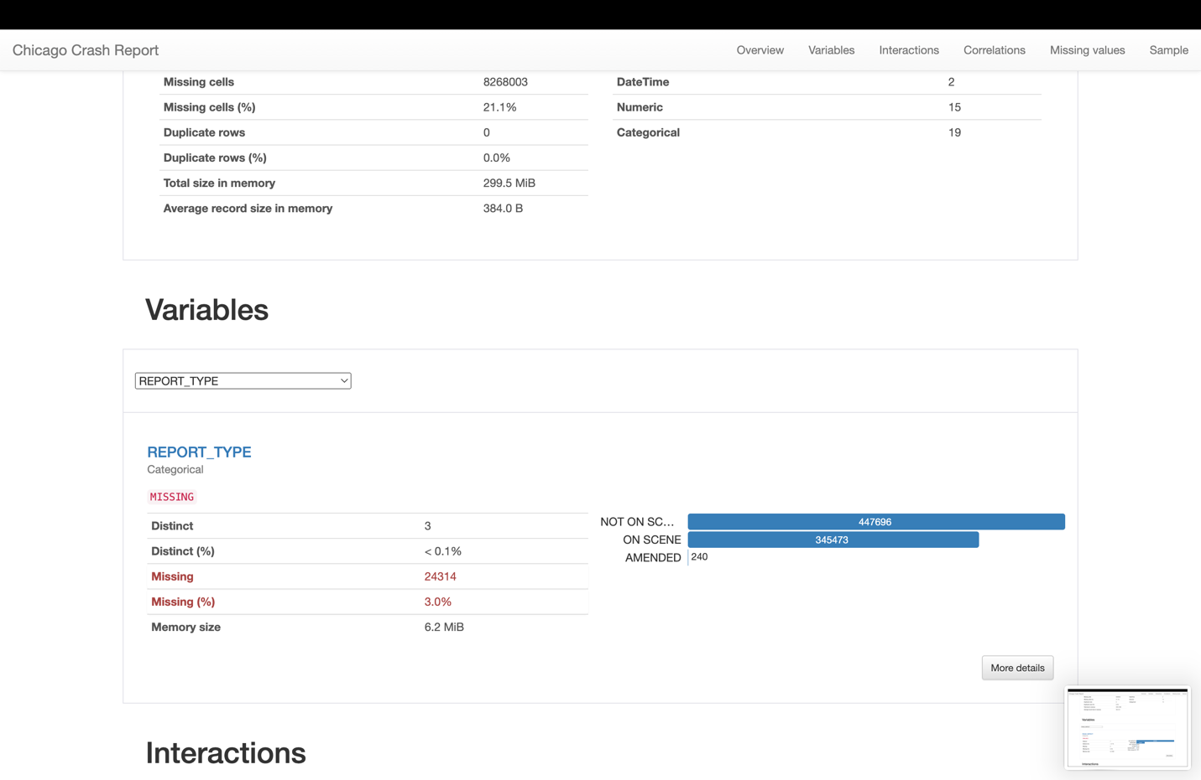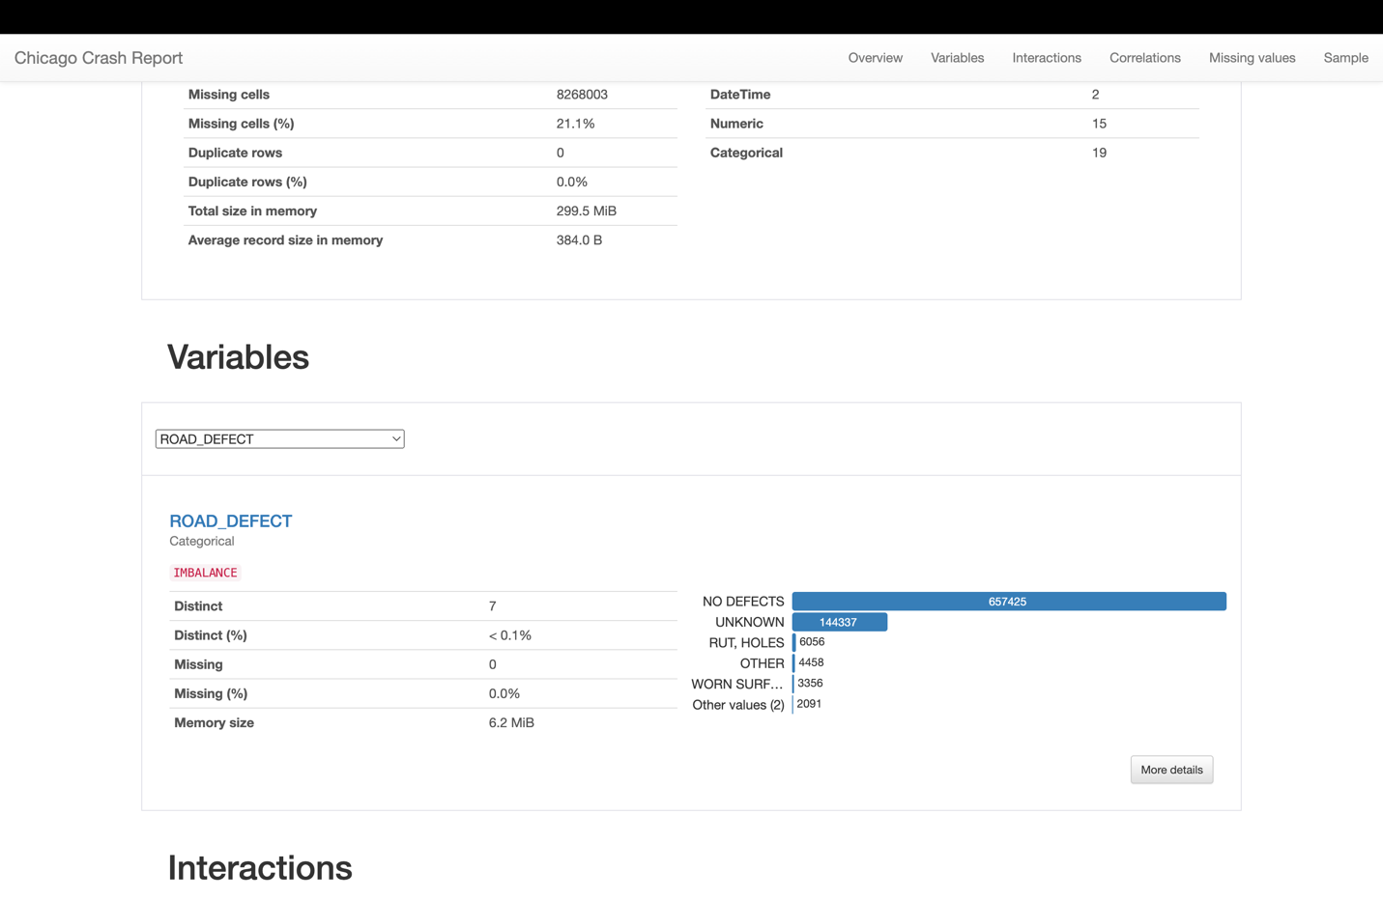

**CRASH_RECORD_ID**

* **Data Completeness:** 0.0% of entries for the CRASH_RECORD_ID are missing, indicating a complete record for this identifier.
* **Distinct Values:** There are 817,723 distinct CRASH_RECORD_ID values present, accounting for 100% distinctness, suggesting every crash has a unique identifier.
* **Characteristics of Data:**
  1. The data likely contains alphanumeric characters to ensure unique identification.
  2. There is only one category, which is the unique identifier for each crash record.
  3. Consistent length of 35 characters for each ID suggests a standardized format.

**ZIP_CODE**

* **Data Completeness:** 31.1% of the entries for the ZIP_CODE variable are missing, impacting analyses requiring geographical segmentation.
* **Distinct Values:** There are 235 distinct ZIP codes in the dataset. A distinctness of less than 0.1% indicates high repetition across ZIP codes, possibly due to higher incident rates in those areas.
* **Length of Values:** All ZIP codes are 5 characters long, which is standard for ZIP codes.
* **Characteristics of Data:**
  1. There are 11 distinct characters used, probably 0-9 and a placeholder for missing data.
  2. The dataset distinguishes between regular and missing or otherwise marked ZIP codes.
  3. The use of a single script and block in Unicode is expected for numeric values.

**HIT_AND_RUN_I**

* **Data Completeness:** 68.7% of entries for HIT_AND_RUN_I are missing, which significantly hinders the reliability of hit-and-run analysis.
* **Distinct Values:** There are only 2 distinct values, indicating a boolean (True/False) setup.
* **Characteristics of Data:**
  1. The data is categorized into two distinct categories: 'True' for confirmed hit-and-run incidents and 'False' for the opposite.
  2. The boolean nature of this field simplifies the analysis for presence or absence of hit-and-run incidents.

**NOT_RIGHT_OF_WAY_I**

* **Data Completeness:** 95.4% of the entries for NOT_RIGHT_OF_WAY_I are missing, questioning the variable's applicability.
* **Distinct Values:** Only 2 distinct values, fitting for a boolean variable.
* **Characteristics of Data:**
  1. This field categorizes incidents into whether they involve a failure to yield the right of way.
  2. Due to the high percentage of missing data, this field may be less reliable for drawing conclusions.

**ROAD_DEFECT**

* **Data Completeness:** No missing entries for ROAD_DEFECT, which allows for complete analysis of road conditions.
* **Distinct Values:** 7 distinct road conditions are identified, indicating a variety of road statuses.
* **Characteristics of Data:**
  1. The categories likely include 'No Defects', 'Unknown', 'Potholes', etc.
  2. This categorical data can correlate road conditions to crash incidents.

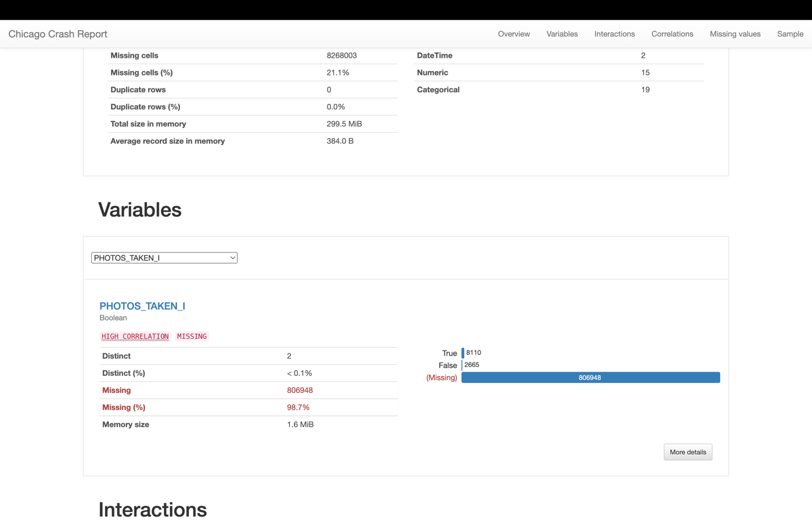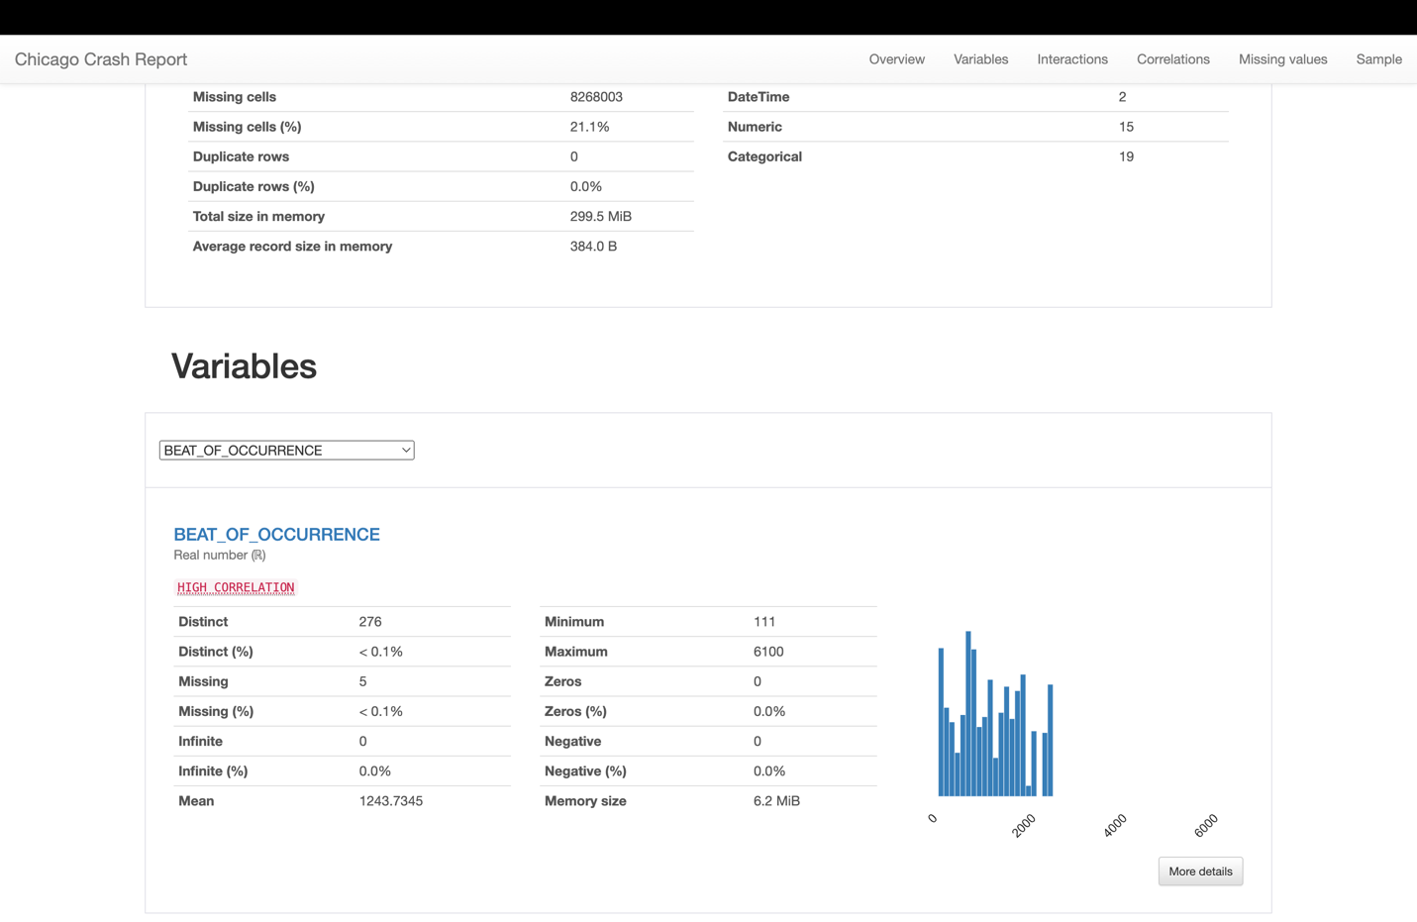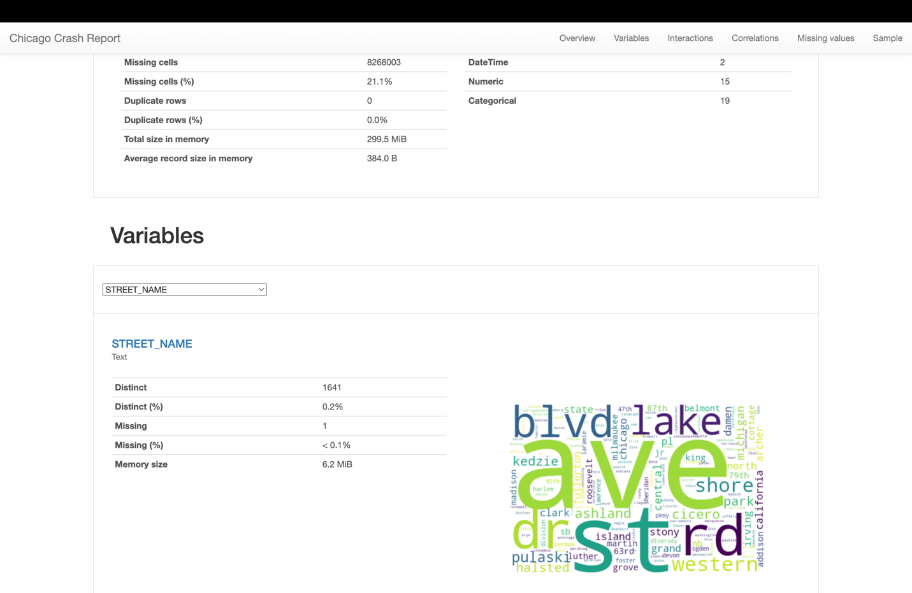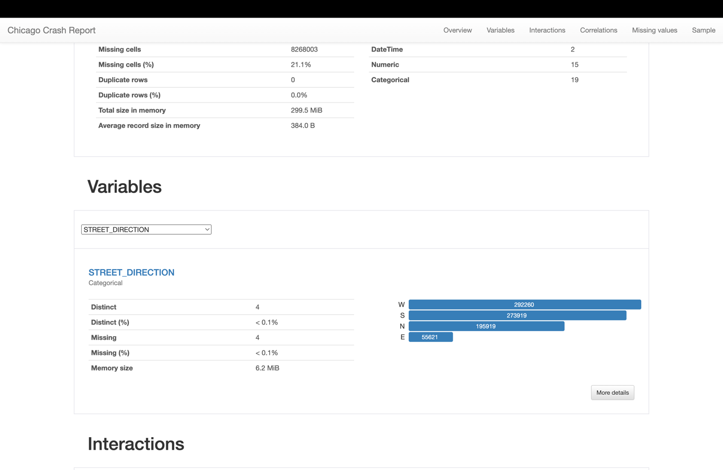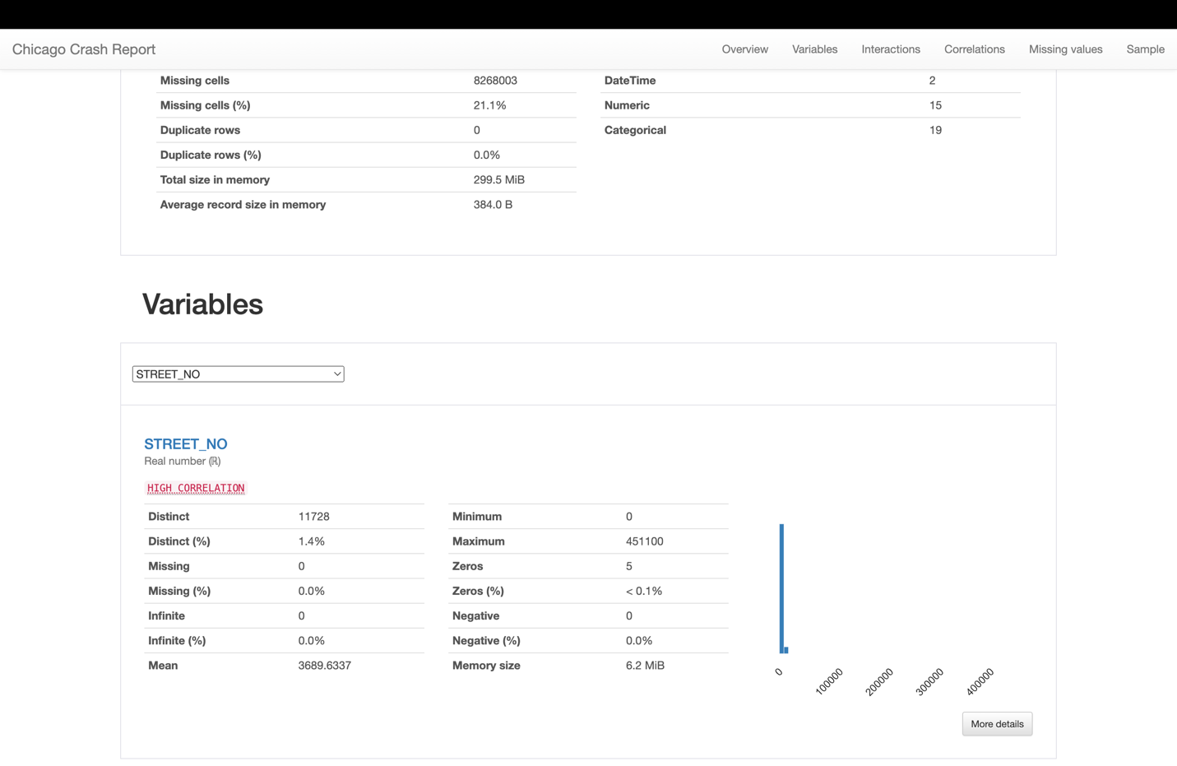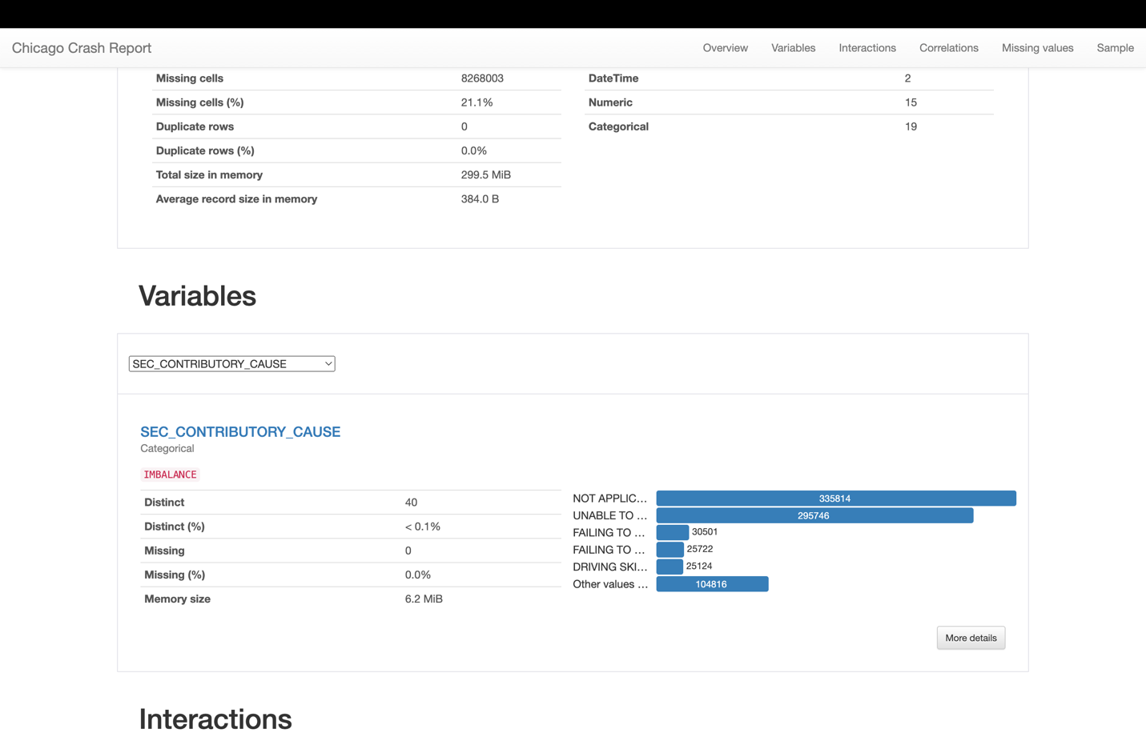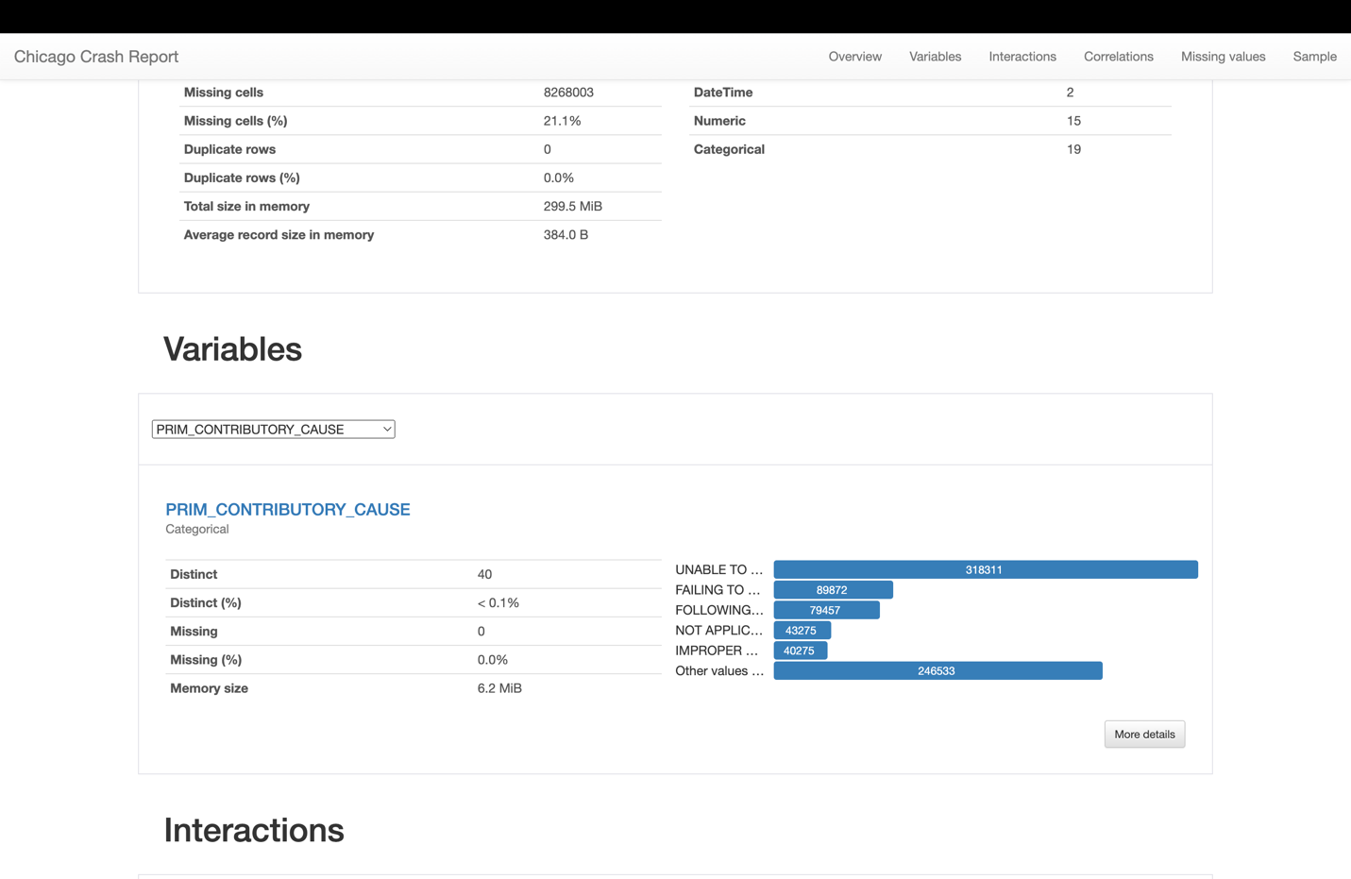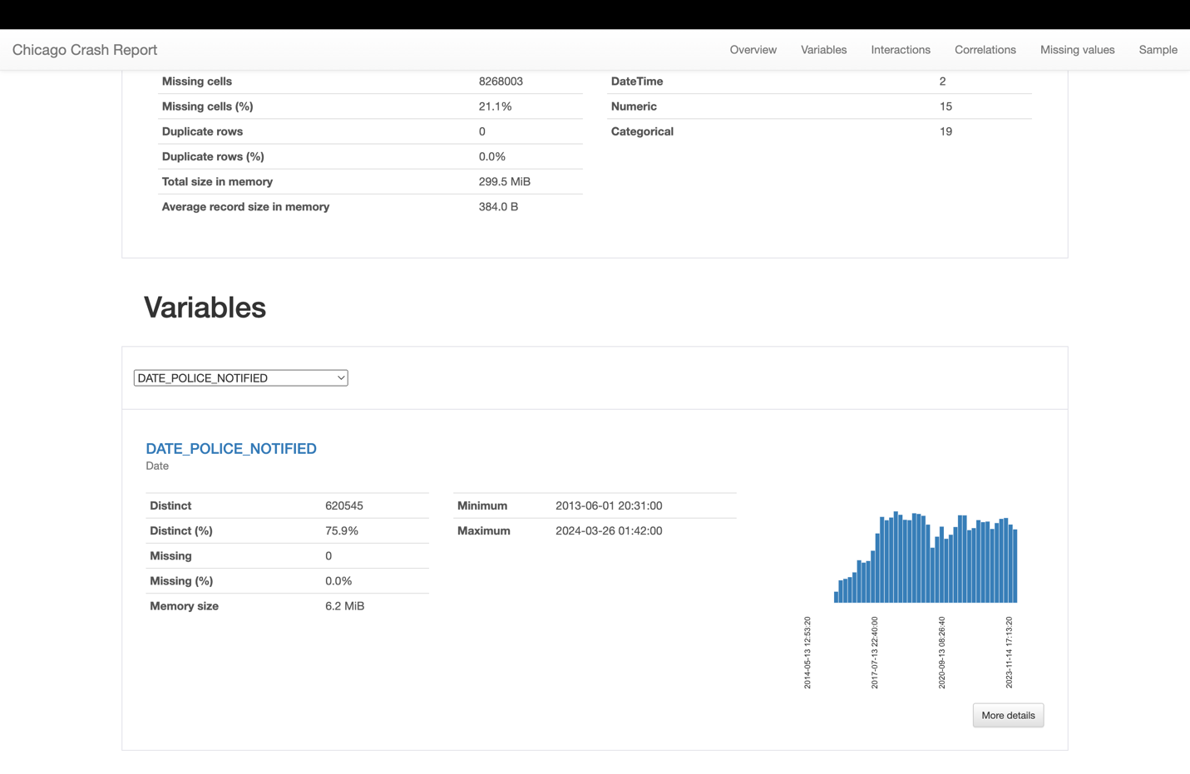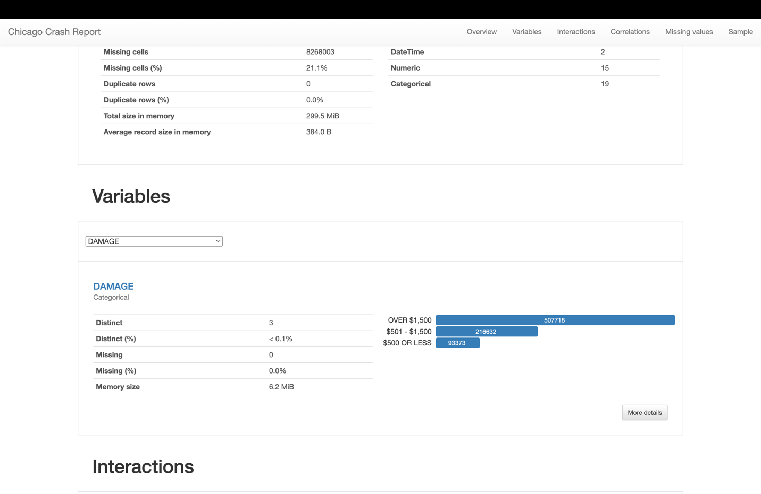

I'll provide an overview of each variable based on the screenshots you've shared, in a format similar to the one you've provided:

**PHOTOS_TAKEN_I**:

* 1. **Data Completeness**: A vast majority of the entries for this boolean variable are missing, with 98.7% not recorded.
  2. **Distinct Values**: There are only 2 distinct values, true and false, as expected for a boolean variable.
  3. **Memory Size**: The data for this variable occupies 1.6 MiB of memory.

**BEAT_OF_OCCURRENCE**:

* 1. **Data Completeness**: There's a high degree of completeness with less than 0.1% missing data.
  2. **Distinct Values**: There are 276 distinct numerical values representing different police beats where occurrences were reported.
  3. **Range**: The numerical values range from 111 to 6100, with a mean value of 1243.7345.

**STREET_NAME**:

* 1. **Data Completeness**: Almost complete with just one entry missing.
  2. **Distinct Values**: There are 1641 distinct text values for street names where crashes have been reported.
  3. **Memory Size**: This variable takes up 6.2 MiB of memory space.

**STREET_DIRECTION**:

* 1. **Data Completeness**: The dataset is nearly complete with only 4 missing entries.
  2. **Distinct Values**: Only 4 distinct categorical values, likely corresponding to the cardinal directions (N, S, E, W).

**STREET_NO**:

* 1. **Data Completeness**: This variable is fully complete with no missing data.
  2. **Distinct Values**: There are 11,728 distinct numerical values for street numbers.
  3. **Range**: The values range from 0 to 451100, indicating a wide variation in the street numbers reported.

**SEC_CONTRIBUTORY_CAUSE**:

* 1. **Data Completeness**: There is no missing data for this categorical variable.
  2. **Distinct Values**: With 40 distinct values, this variable captures a range of secondary contributory causes for the crashes.

**PRIM_CONTRIBUTORY_CAUSE**:

* 1. **Data Completeness**: Complete with no missing entries.
  2. **Distinct Values**: Also contains 40 distinct values, which enumerate the primary causes of the crashes.

**DATE_POLICE_NOTIFIED**:

* 1. **Data Completeness**: Fully complete with no missing data.
  2. **Distinct Values**: There are 62,045 distinct datetime values, indicating the timestamp when the police were notified of the crashes.

**DAMAGE**:

* 1. **Data Completeness**: There are no missing entries for this variable.
  2. **Distinct Values**: It has 3 distinct categorical values that describe the extent of damage, such as "OVER $1,500", "$501 - $1,500", and "$500 OR LESS".

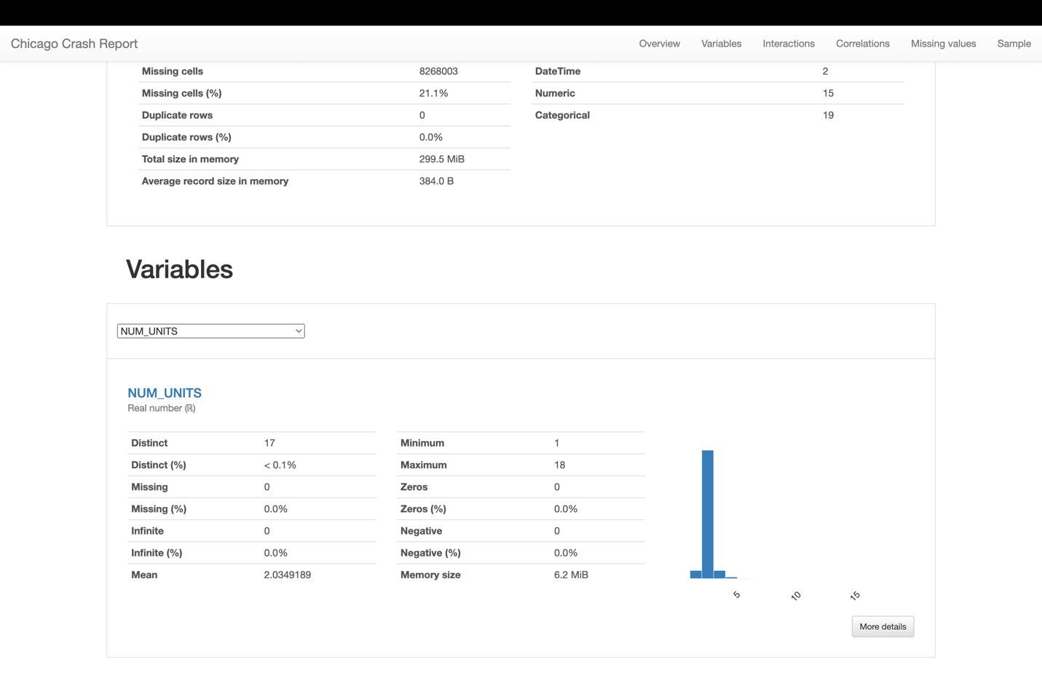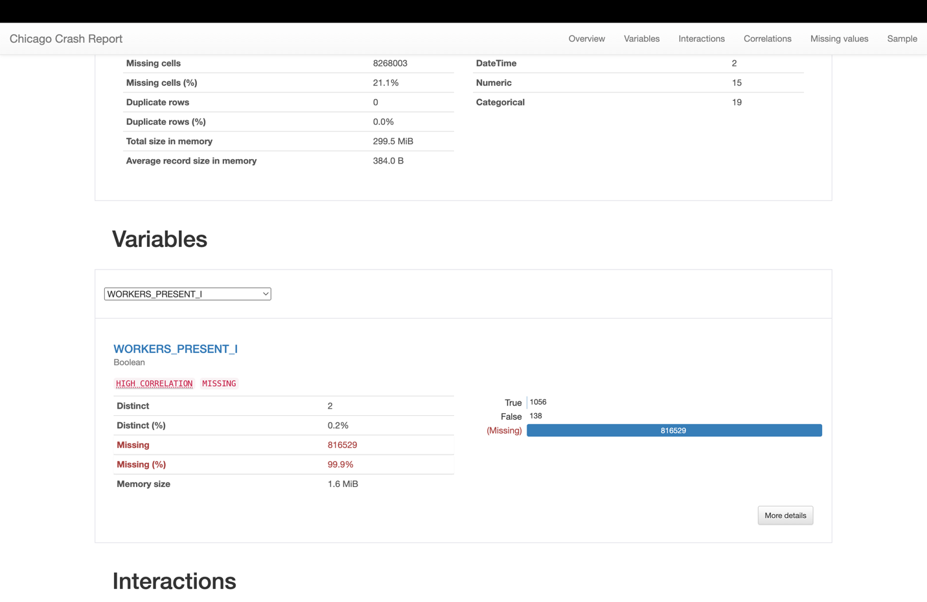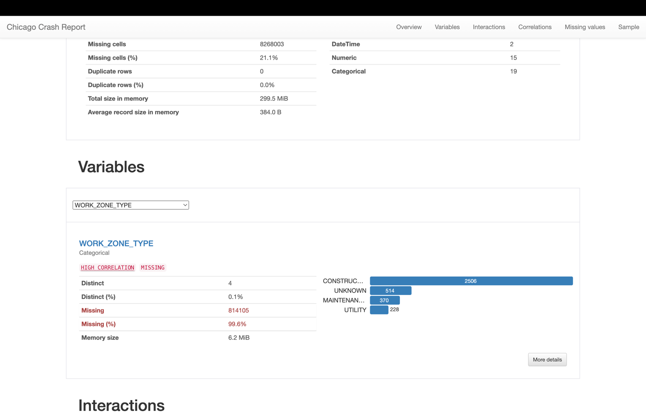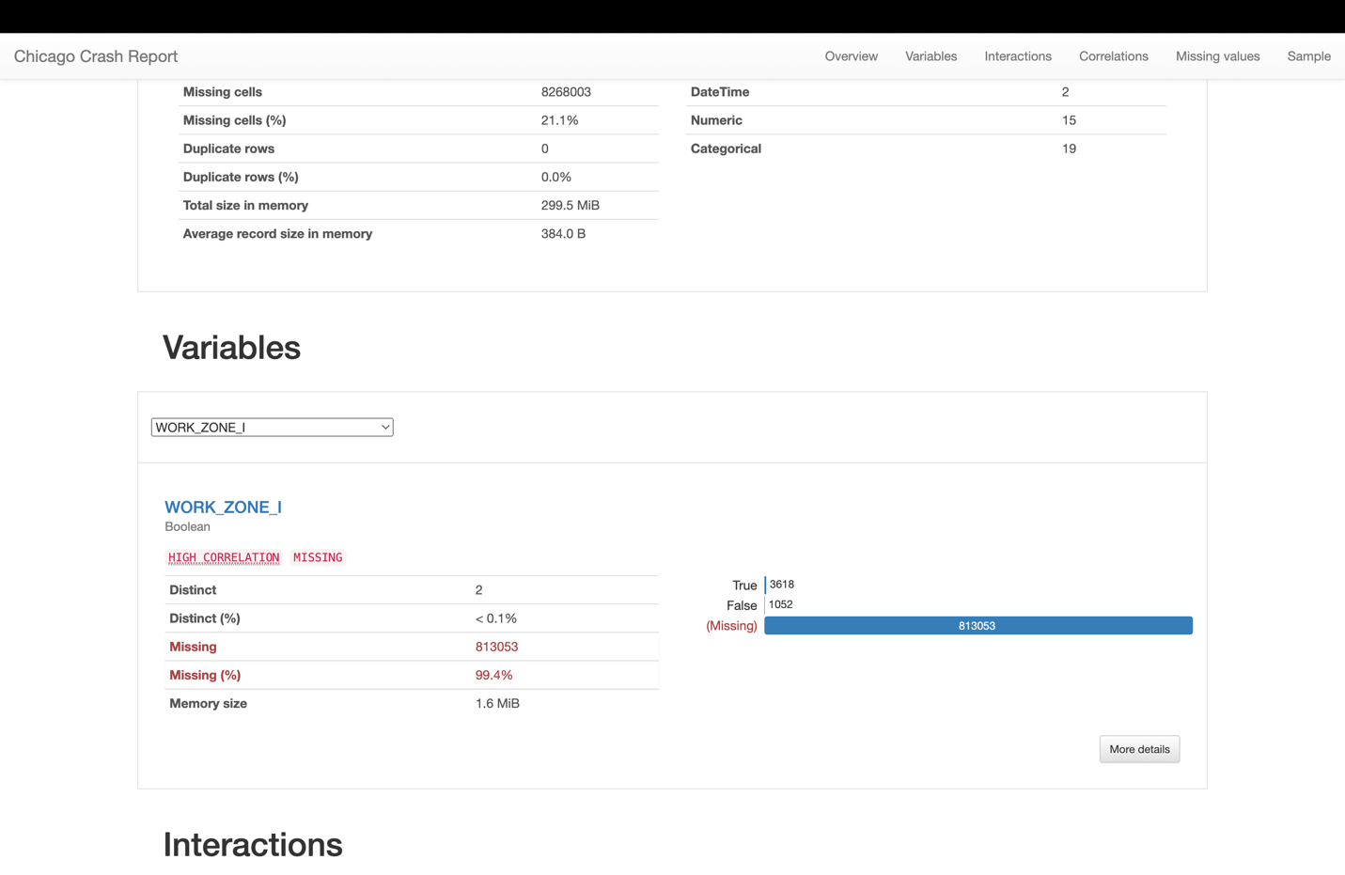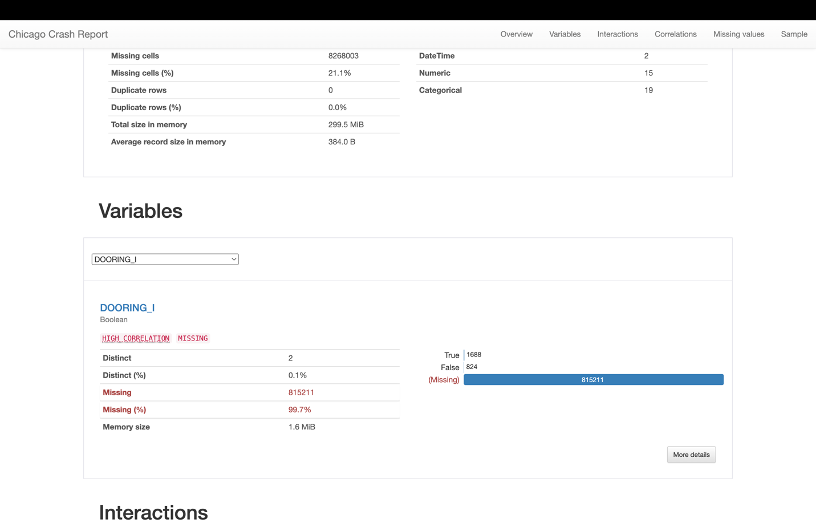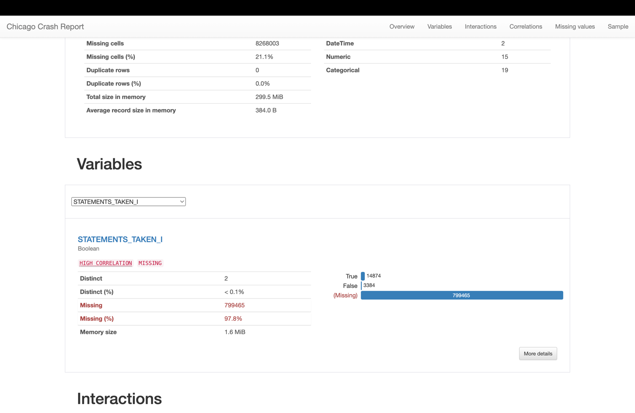

**NUM_UNITS**

* **Distinct Values:** There are 17 distinct values with less than 0.1% distinctness, suggesting limited variation.
* **Missing Data:** There are no missing values, indicating complete data for this variable.
* **Data Distribution:** The data distribution is highly concentrated around a lower number, as indicated by the histogram, with the mean being around 2.

**WORKERS_PRESENT_I**

* **Distinct Values:** Only 2 distinct values, indicating a boolean type of data.
* **Missing Data:** A vast majority of the data is missing (99.9%), which may limit the usefulness of this variable for analysis.

**WORK_ZONE_TYPE**

* **Distinct Values:** 4 distinct categories, with very few entries compared to the size of the dataset.
* **Missing Data:** High level of missing data at 99.6%, again suggesting limited applicability in analysis.

**WORK_ZONE_I**

* **Distinct Values:** There are 2 distinct values, indicating this is a boolean field.
* **Missing Data:** There's a high percentage of missing data (99.4%), which could affect analyses involving work zone indicators.

**DOORING_I**

* **Distinct Values:** Again, only 2 distinct values, consistent with boolean variables.
* **Missing Data:** Extremely high missing rate at 99.7%, which makes this variable of limited use for most analyses.

**STATEMENTS_TAKEN_I**

* **Distinct Values:** Only 2 distinct values are present.
* **Missing Data:** A high missing rate of 97.8%, indicating that for the vast majority of records, it's not documented whether statements were taken.

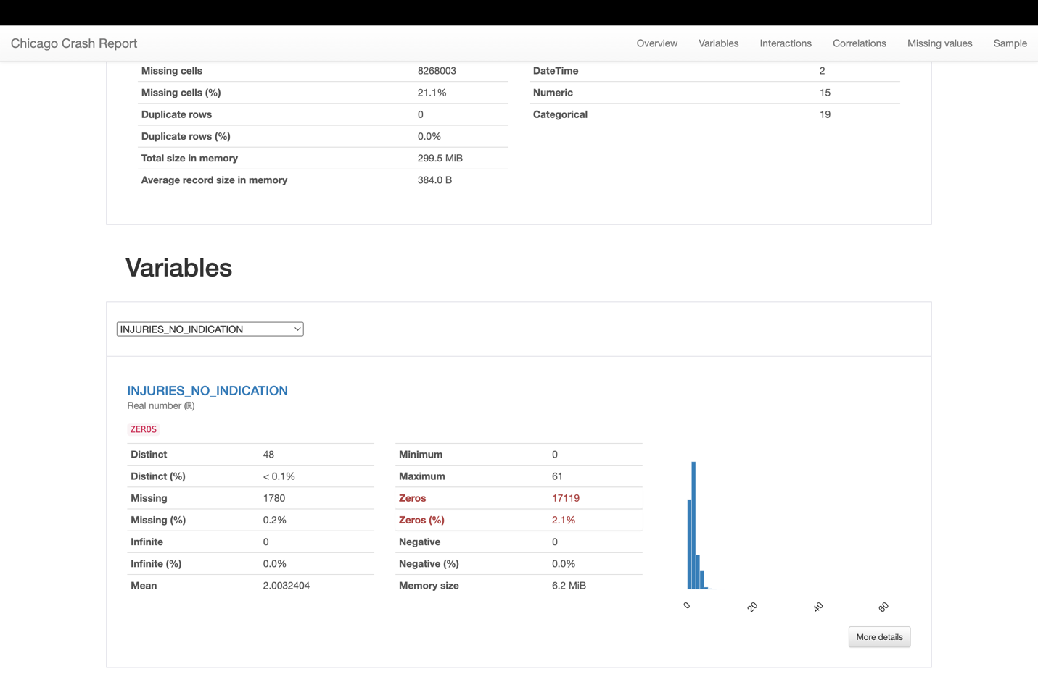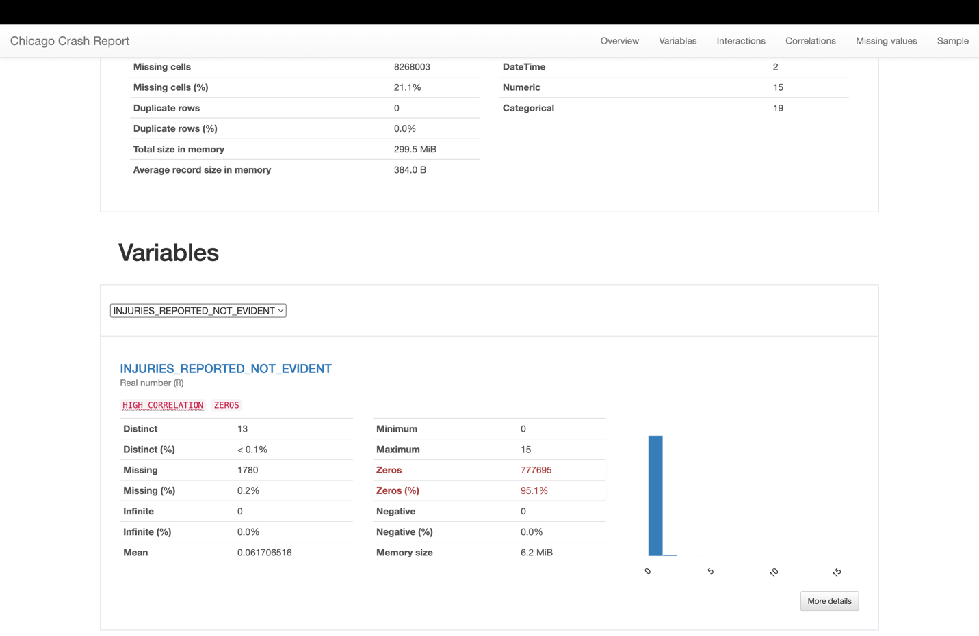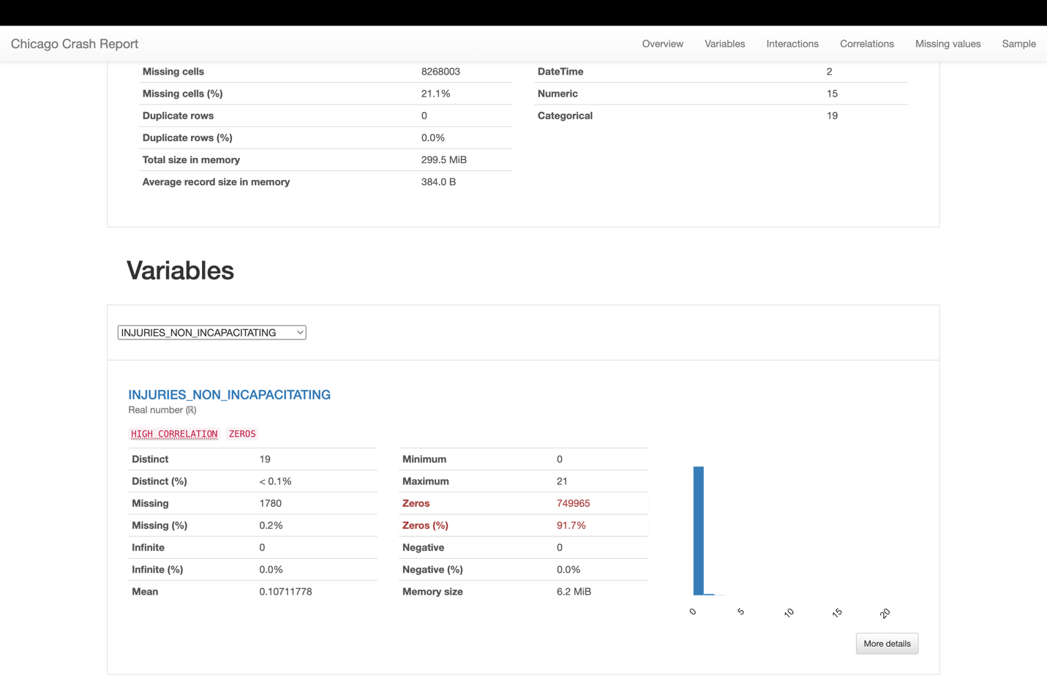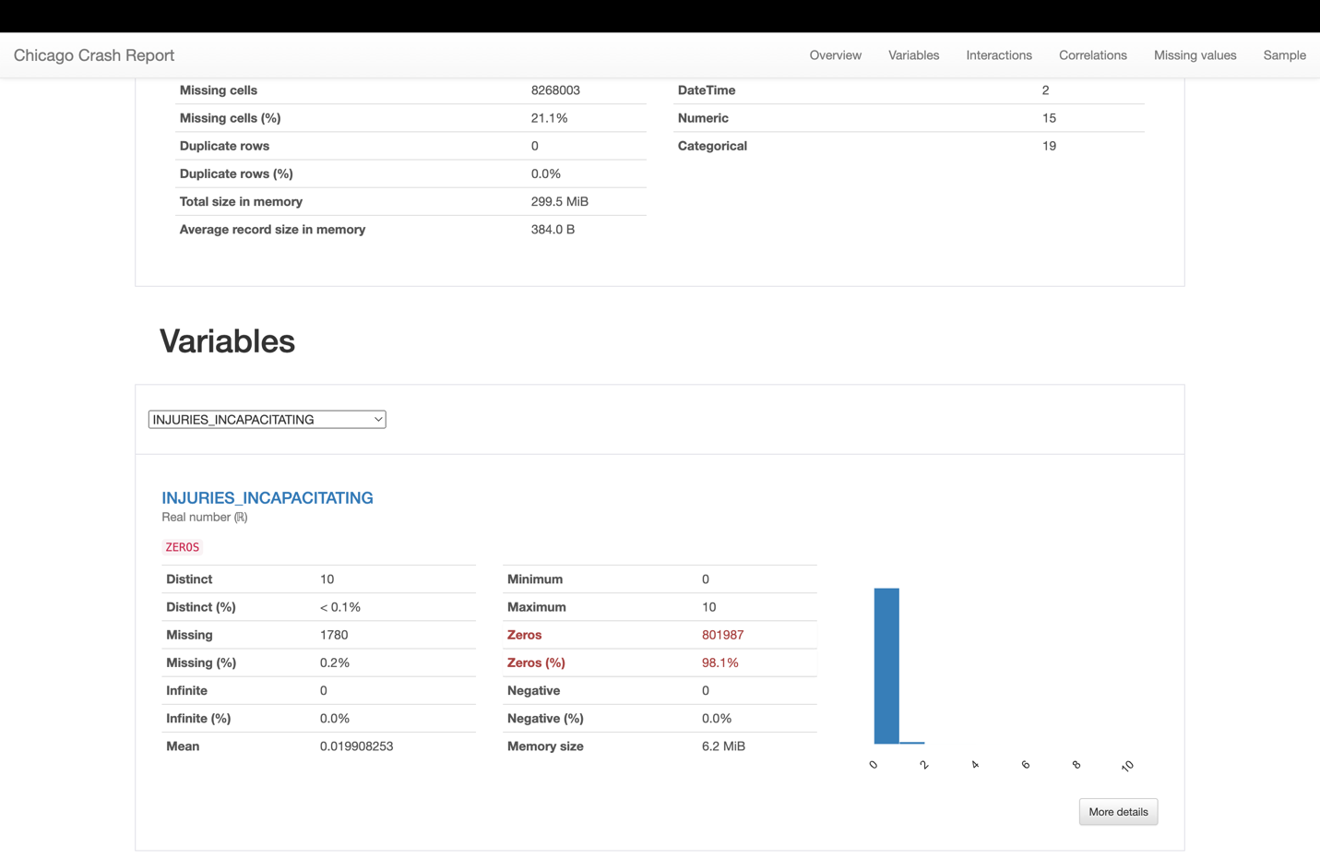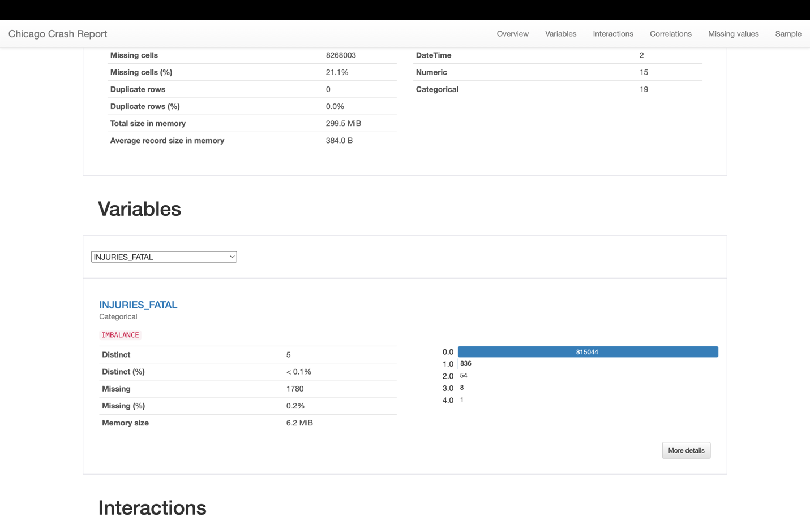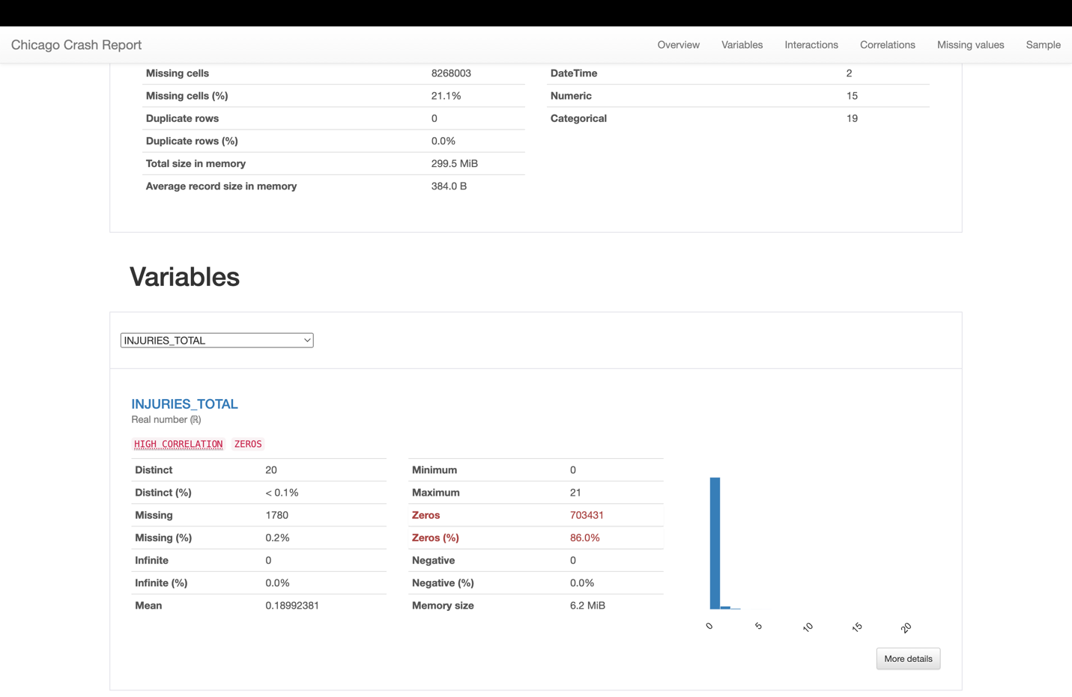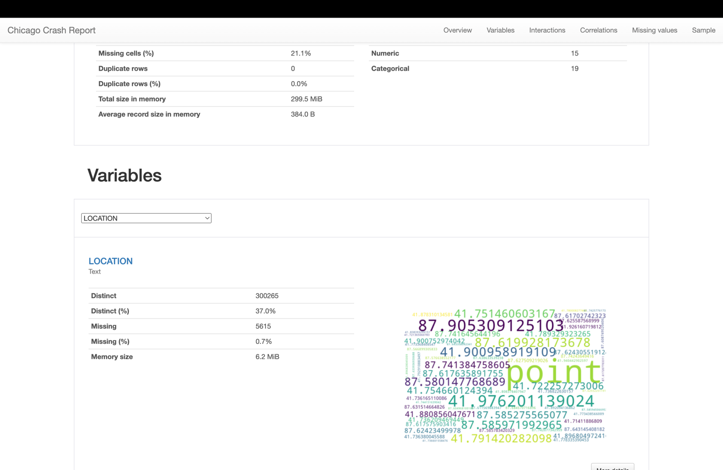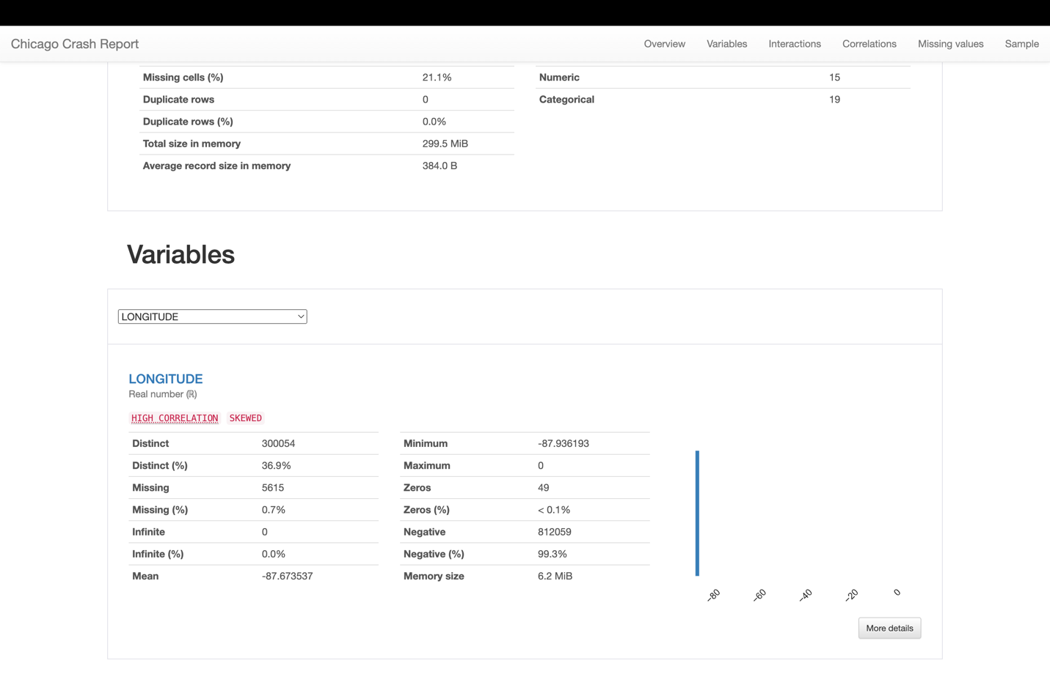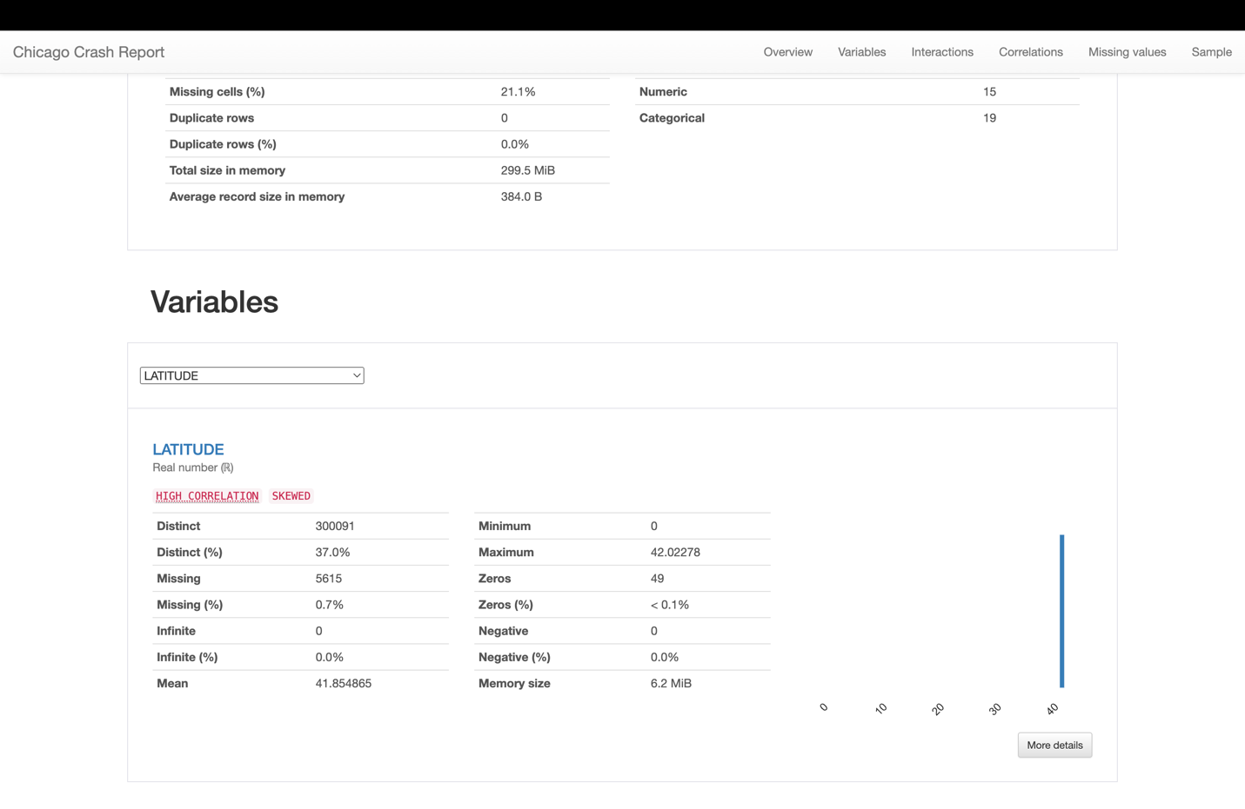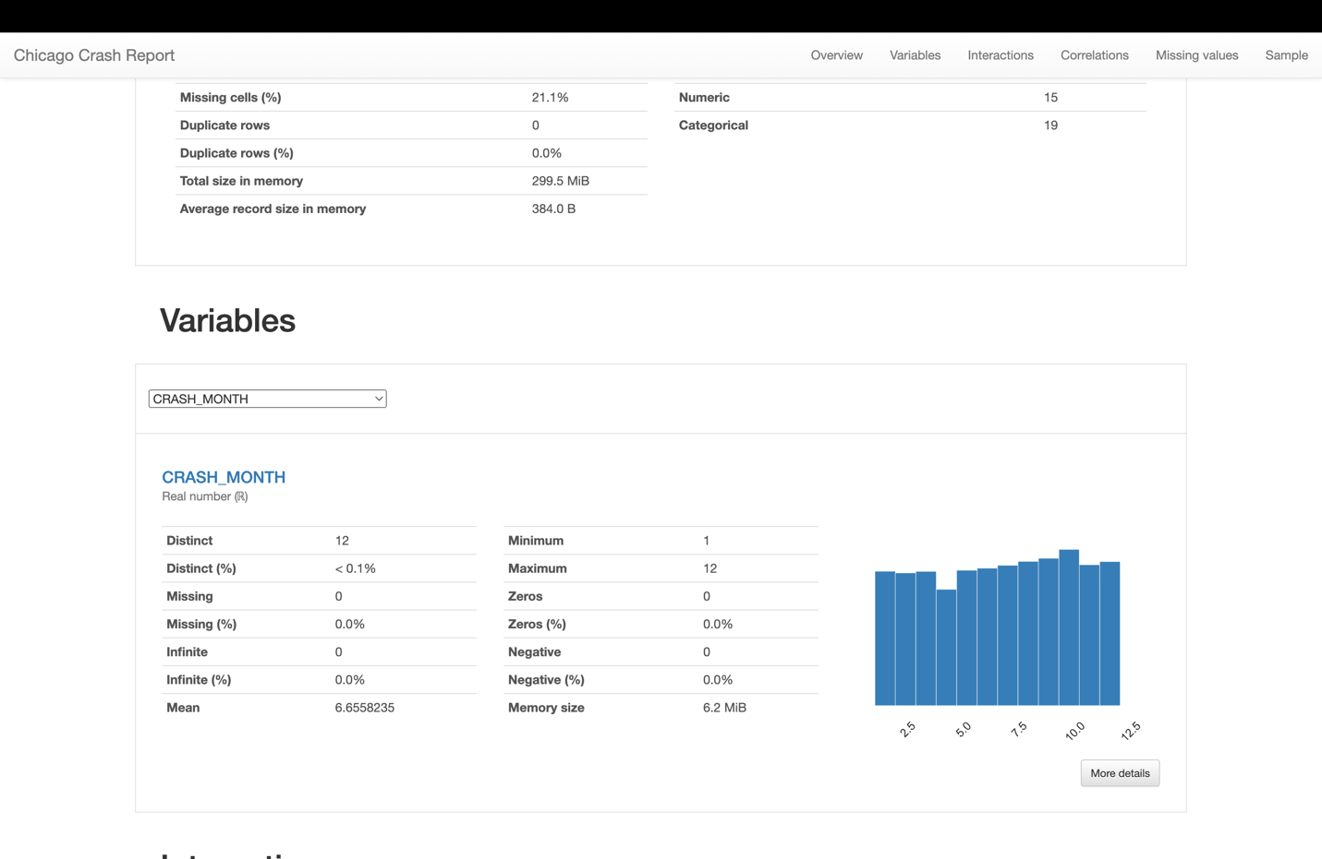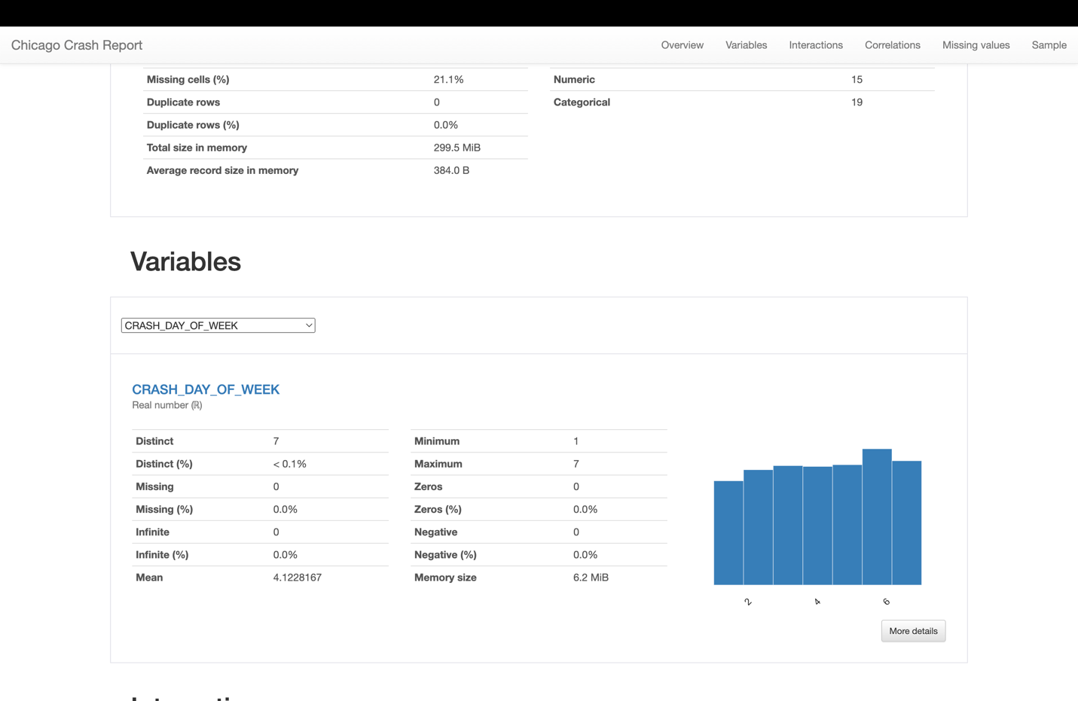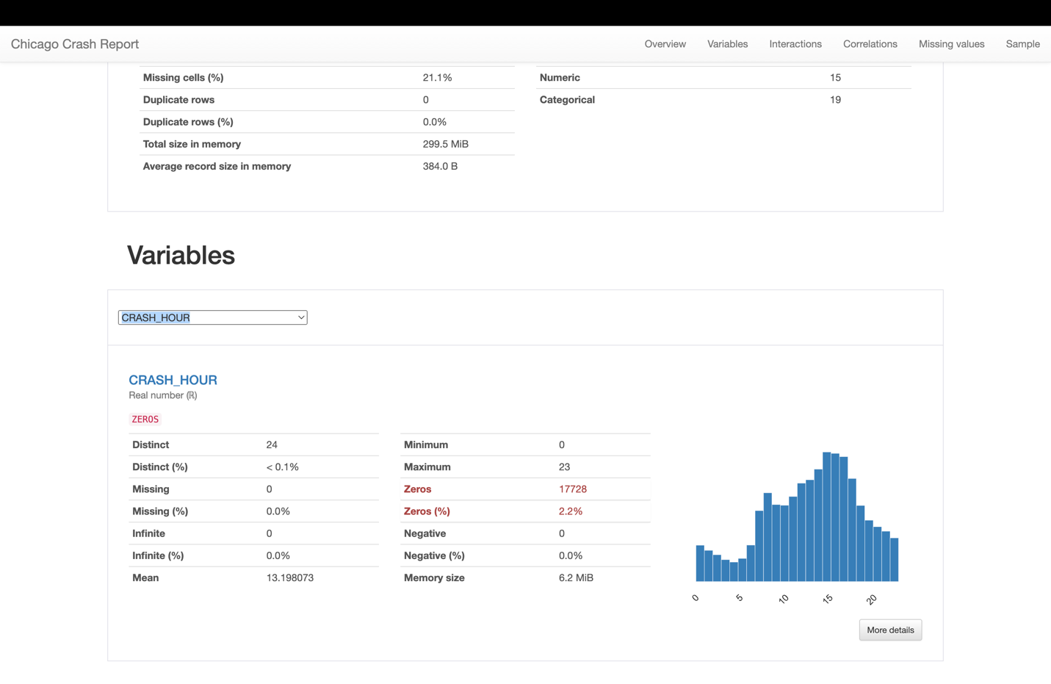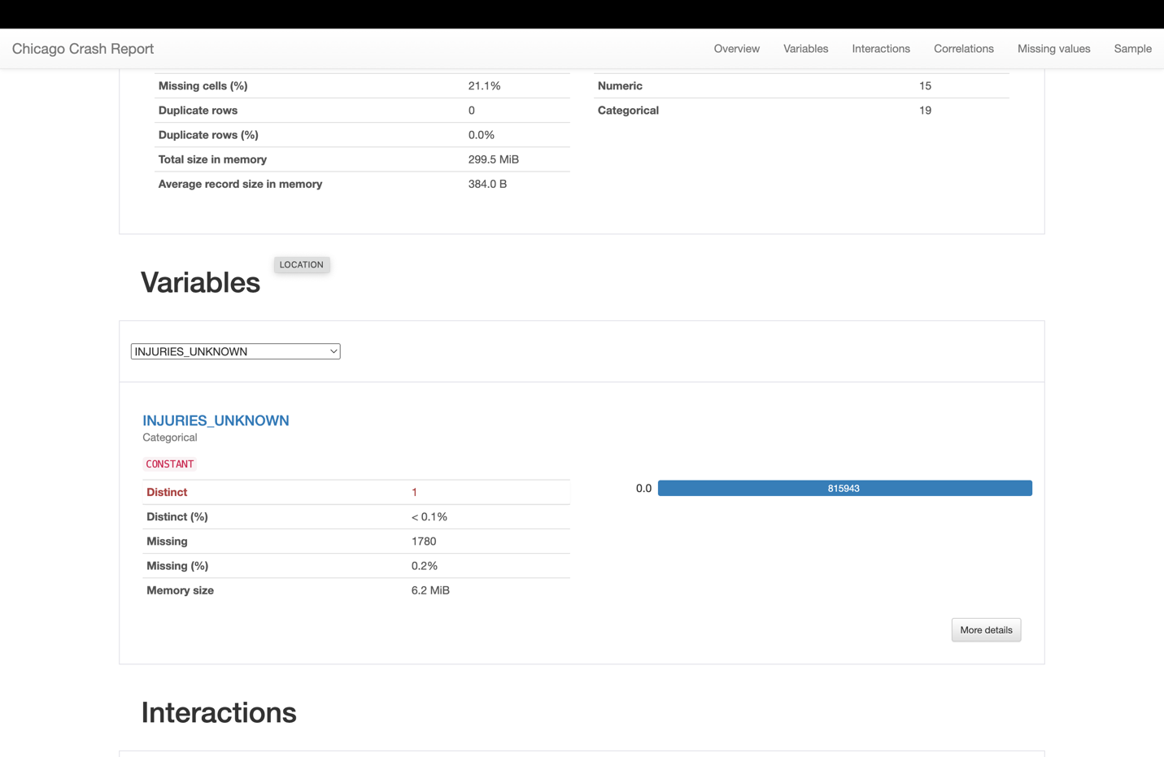

* **INJURIES_NO_INDICATION**:
  1. Distinct values: 48
  2. Missing values: A small number, indicating that this field is usually reported.
  3. Zeros represent a significant proportion, indicating that for many crashes, there were no injuries reported at the scene.
* **INJURIES_REPORTED_NOT_EVIDENT**:
  1. Distinct values: 13
  2. Missing values: Similar to INJURIES_NO_INDICATION, there are a few missing values.
  3. Most values are zeros, suggesting that in most cases, there are no obvious injuries even if reported.
* **INJURIES_NON_INCAPACITATING**:
  1. Distinct values: 19
  2. Missing values: Again, a small number.
  3. The majority of the cases report zero non-incapacitating injuries, indicating they are not common.
* **INJURIES_INCAPACITATING**:
  1. Distinct values: 10
  2. Missing values: Small in number.
  3. A large majority of crashes have zero incapacitating injuries, but the presence of non-zero values indicates more serious crashes.
* **INJURIES_FATAL**:
  1. Distinct values: 5
  2. Missing values: Small in number.
  3. Most crashes have zero fatalities, with a very small number resulting in one or more deaths.
* **INJURIES_TOTAL**:
  1. Distinct values: 20
  2. Missing values: Small in number.
  3. The majority of reported crashes have no injuries, as indicated by the high number of zeros.
* **MOST_SEVERE_INJURY**:
  1. Distinct values: 5 (Categories of injury severity)
  2. Missing values: Small in number.
  3. The data indicates that most crashes either have no injuries or non-incapacitating injuries.



**Location Data (Latitude and Longitude)**

* The dataset includes geographic location data for the crashes.
* There are over 300,000 distinct values for both latitude and longitude, which suggests a wide variety of crash locations within Chicago.
* The histograms for both latitude and longitude show that data points are concentrated within specific ranges, likely corresponding to more densely populated or high-traffic areas.
* A small percentage (0.7%) of location data is missing, which is relatively minor but still important for complete spatial analysis.

**Time Data (Crash Month, Day of Week, Hour)**

* The CRASH_MONTH variable indicates crashes occur throughout all months of the year, with each month represented.
* The CRASH_DAY_OF_WEEK variable shows that crashes happen across all days of the week, with the numbers suggesting a relatively even distribution.
* The CRASH_HOUR histogram indicates a pattern in the timing of crashes, with fewer crashes occurring in the early morning hours and a peak in the late afternoon/evening, which could correlate with rush hour traffic.

**Injury Data (Injuries Unknown)**

* The INJURIES_UNKNOWN variable seems to be a categorical variable with a single constant value; this might suggest that this field was not used or not applicable in the dataset.

**General Observations**

* The data does not contain any duplicate rows, which is beneficial for analysis as it implies each record is a unique incident.
* The total size of the dataset in memory is around 300 MB with an average record size of 384 bytes, indicating a moderately large dataset.
* The missing cells percentage for the entire dataset is 21.1%, which is quite significant. Depending on which variables these missing values correspond to, this could impact the reliability of certain types of analysis.